- The correct answer is:

C. 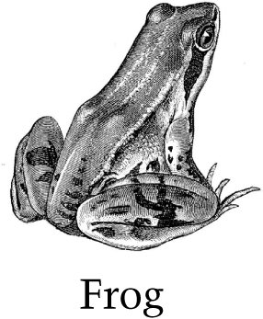

- The correct answer is:

B. 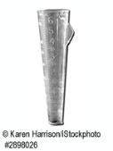

- The correct answer is:

B. Where the birds travel

- The correct answer is:

C. The color of the feathers blends into the birds' surroundings and helps the birds avoid predators.

- Item Detail - Question Scoring Guide

Complete
Student response selects (B) Day 2 and (C) Day 3 and no other days and indicates understanding the relationship between the temperature data and the weather for all four days. On Days 2 and 3, the temperatures were cool and did not change much during the day, or the clouds blocked the Sun's heat; and on Days 1 and 4, the temperatures were warm and increased during the day, or there were no clouds to block the Sun's heat.

Partial
Student response selects (B) Day 2 and (C) Day 3 and no other days and indicates understanding the relationship between the temperature data and the weather for at least one of the four days.
OR
Student response selects (B) Day 2 and (C) Day 3 and no other days and provides no explanation.
OR
Student response selects (B) Day 2 or (C) Day 3 and no other days and indicates understanding the relationship between the temperature data and the weather for at least one of the four days.

Unsatisfactory/Incorrect
Student response is inadequate or incorrect.

- The correct answer is:

D. The sunlight making the sidewalk warmer than the air

- Item Detail - Question Scoring Guide

Complete
Student response selects (B) and indicates that Carmen varied the amount of sunlight and kept the amount of water added and the temperature of the environment the same. Response also indicates that Michael could learn how temperature affects plant growth.

Essential
Student response selects (B) and indicates that Carmen varied the amount of sunlight and kept the amount of water added and the temperature of the environment the same.
OR
Student response selects (B) and indicates that Carmen varied the amount of sunlight. Response also indicates that Michael could learn how temperature affects plant growth.
OR
Student response selects (B) and indicates that Carmen kept the amount of water added and the temperature of the environment the same. Response also indicates that Michael could learn how temperature affects plant growth.
OR
Student response selects (B) and indicates that Michael could learn how temperature affects plant growth.

Partial
Student response selects (B) and indicates that Carmen varied the amount of sunlight.
OR
Student response selects (B) and indicates that Carmen kept the amount of water added and the temperature of the environment the same.

Unsatisfactory/Incorrect
Student response is inadequate or incorrect.

- Item Detail - Question Scoring Guide

Complete
Student response indicates two plausible ways people can reduce the amount of harmful gases released from burning fossil fuels. Responses may state ways to reduce the amount of fossil fuels used or to use cleaner alternative fuels or technologies. Individual actions and societal actions are acceptable.

Partial
Student response indicates one plausible way people can reduce the amount of harmful gases released from burning fossil fuels.

Unsatisfactory/Incorrect
Student response is inadequate or incorrect.

- The correct answer is:

    - 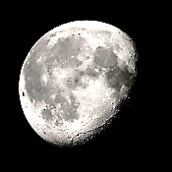

- Item Detail - Question Scoring Guide

Complete
Student response selects (A) Cup A and either indicates that the water in Cup A evaporated less because the temperature in the room is warmer than in the refrigerator, or indicates that the water in Cup A expands as it freezes.
OR
Student response selects (B) Cup B and indicates that the water in Cup B evaporated more because the air in the refrigerator is drier than in the room.

Partial
Student response is partially correct.

Unsatisfactory/Incorrect
Student response is inadequate or incorrect.

- Item Detail - Question Scoring Guide

Complete
Student response indicates either that sand with lighter color reflects more sunlight than sand with darker color, or that sand with lighter color absorbs less sunlight than sand with darker color.

Partial
Student response recognizes that the color of the sand influences the sand's temperature, but does not relate the temperature difference to absorption or reflection of sunlight.
OR
Student response recognizes that different colors absorb or reflect different amounts of sunlight, but does not specify which colors absorb or reflect more sunlight.

Unsatisfactory/Incorrect
Student response is inadequate or incorrect.

- The correct answer is:

C. Pour all of the water from Cup 1 into Cup 2 to see if the water completely fills Cup 2 without spilling over

- Item Detail - Question Scoring Guide

Complete
Student response indicates that the water evaporated or boiled. Response also indicates that the water went into the atmosphere.

Partial
Student response indicates that the water evaporated or boiled.
OR
Student response indicates that the water went into the atmosphere.

Unsatisfactory/Incorrect
Student response is inadequate or incorrect.

- The correct answer is:

B. Cat

- The correct answer is:

A. 1

- The correct answer is:

B. B

