- Item Detail for Question 1
  - No student responses are available for this question.

- Item Detail for Question 2
  - No student responses are available for this question.

- Item Detail for Question 3

Complete - Student Response
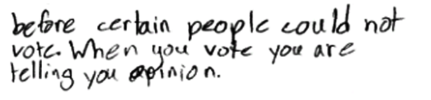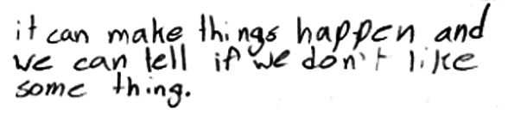

-------------------------------------------------------------------------------------------------------------------------------------------------------------------------

These responses provided two rights of citizens of the United States and an explanation why each right is important. The first response refers to the right to vote and the right of peaceable public assembly. The first part of the second response refers to freedom of religion, which is a right protected in the Bill of Rights. The second right listed was interpreted as freedom of speech, which is also protected in the Bill of Rights.
Acceptable - Student Response

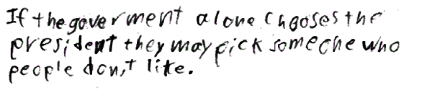
These responses provided one or two rights of citizens with an explanation for one. The first response received credit for Right 1 and its explanation because the explanation recognizes the fact that it is the right of the people to express their views on how they are governed. The response did not receive credit for Right 2. Laws are necessary for a civil society, but they do not constitute a "right" of citizens of the United States. The second response received credit for the first right listed and its explanation, but did not receive credit for the second right ("The government"), which does not refer to a specific right.

Partial - Student Response

-------------------------------------------------------------------------------------------------------------------------------------------------------------------------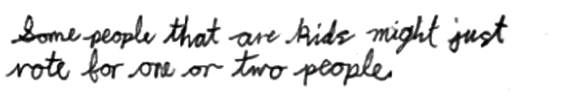

These responses provided one or two rights with no explanations. The first response refers to the right of freedom of speech, but provides no explanation. The second right listed ("The right to respect others") refers to a responsibility of citizens, not a right. The second response refers to the right to vote, but the explanation for the importance of this right does not address why is important that citizens have this right. The second right listed ("You can't litter") refers to a responsibility of citizens, not a right.

Unacceptable - Student Response
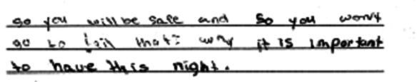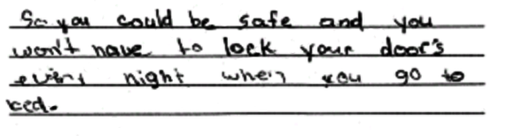

-------------------------------------------------------------------------------------------------------------------------------------------------------------------------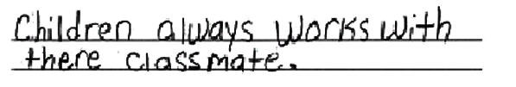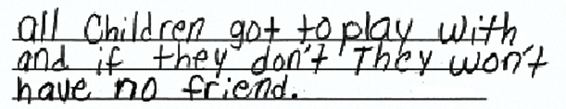

These responses did not provide any rights of citizens or any explanations why the rights are important. The first response provides actions citizens should take, but does not include any rights of citizens of the United States. The second response refers to actions students should take in the classroom, but does not refer to their role in a democratic system.

- Item Detail for Question 4
No student responses are available for this question.

- Item Detail for Question 5
No student responses are available for this question.

- Item Detail for Question 6

Complete - Student Response
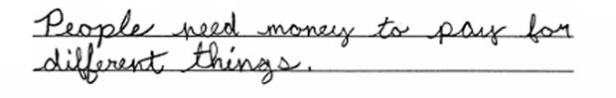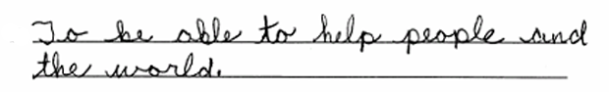

-------------------------------------------------------------------------------------------------------------------------------------------------------------------------

These responses provide two reasons why it is important for people to have work. The first response refers to the need to earn money for essential purchases and also to the fact that, by working, people who have jobs can help other people. The second response refers to the importance of people to have responsibilities and also to the financial importance of having a job.

Partial - Student Response
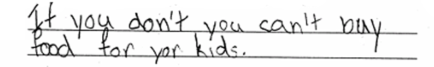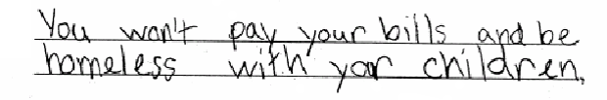

-------------------------------------------------------------------------------------------------------------------------------------------------------------------------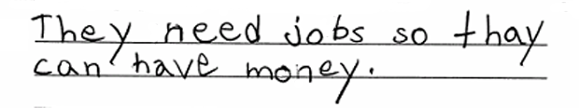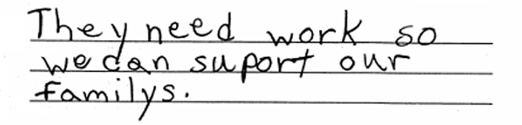

These responses provided one credited reason why it is important for people to have work. In each case, the first part of the first response refers to the economic need to work. No credit was awarded for the second reasons provided in each of the two responses because they provided the same general topic (financial reasons) listed in the first part of the response.

Unacceptable - Student Response
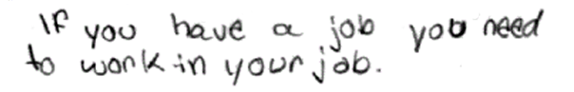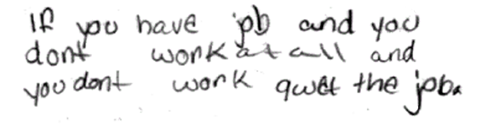

-------------------------------------------------------------------------------------------------------------------------------------------------------------------------

These responses failed to provide a reason why it is important for people to have work. Each response provides comments on working and jobs that were irrelevant to the prompt that was provided.

- Item Detail for Question 7
No student responses are available for this question.

- Item Detail for Question 8
No student responses are available for this question.

- Item Detail for Question 9

Complete - Student Response
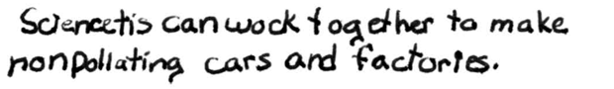

-------------------------------------------------------------------------------------------------------------------------------------------------------------------------

These responses provide two different ways in which countries can help one another deal with the problems listed.

Partial - Student Response

-------------------------------------------------------------------------------------------------------------------------------------------------------------------------

These responses provided one way in which countries can help one another deal with the problems listed. The first part of the first response received credit for suggesting that having a meeting would be a way in which countries could help one another. The statement provided in the second part ("they can talk about it") was considered an elaboration of the first solution provided and was therefore not awarded credit as a second solution. The first part of the second response received credit for suggesting that countries could discuss the problem with one another. The second solution provided in the response was not credited.

Unacceptable - Student Response

-------------------------------------------------------------------------------------------------------------------------------------------------------------------------

These responses failed to provide any ways in which countries can help one another deal with the problems listed. In each case, the responses provided only elaborations or descriptions of the problems without proposing any ways in which countries could help one another find solutions.

- Item Detail for Question 10
No student responses are available for this question.

- Item Detail for Question 11
No student responses are available for this question.

- Item Detail for Question 12
No student responses are available for this question.

- Item Detail for Question 13
No student responses are available for this question.

- Item Detail for Question 14
No student responses are available for this question.

- Item Detail for Question 15
No student responses are available for this question.

