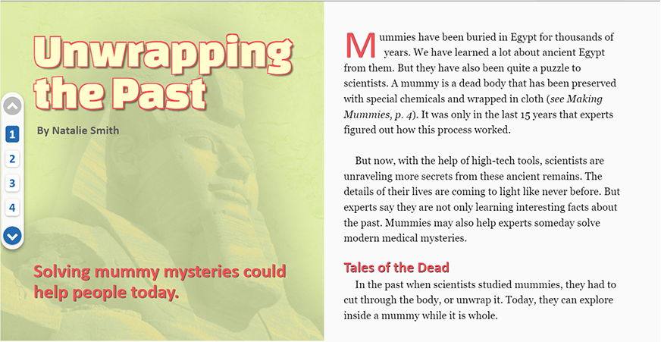
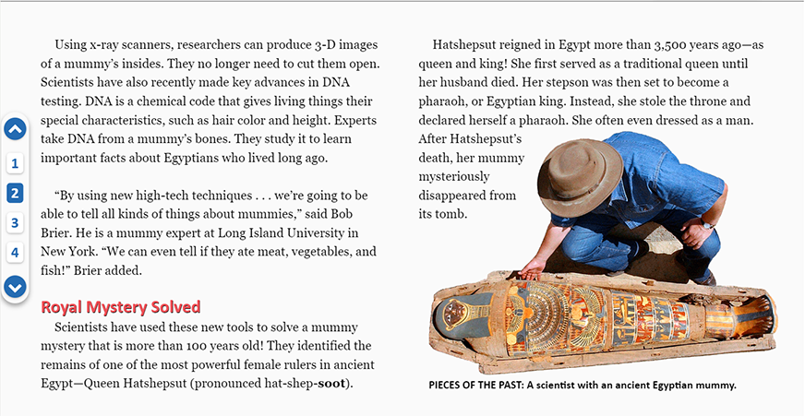
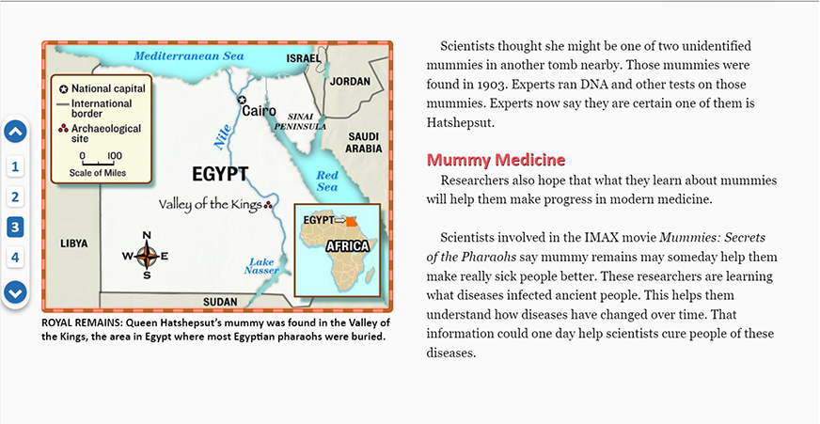
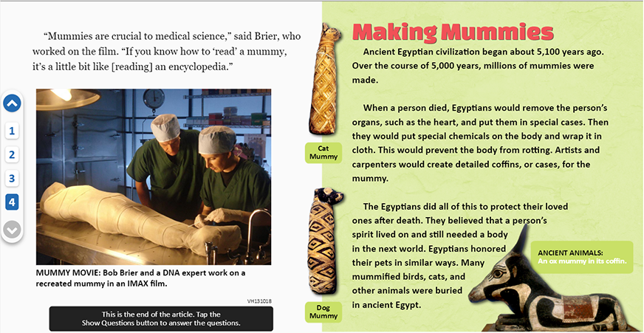

From SCHOLASTIC NEWS, October 29, 2007. Copyright © 2007 by Scholastic Inc. Reprinted by permission of Scholastic Inc. Map of Egypt with inset of Africa from SCHOLASTIC NEWS, October 29, 2007. Copyright © 2007 by Scholastic Inc. Reprinted by permission of Scholastic Inc. Mideast Egypt Mummy Uncovered © AP Photo/Amr Nabil #05050301444. Dr. Bob Brier and Dr. Angelique Corthals in the LA Lab extracting samples for DNA analysis from Giant Screen Films. Sarcophagus of an ox mummy © Alinari Archives/The Image Works #EALN0888804. Mummy of a dog and a cat © Topham/The Image Works #ETPM0245932.

- What is the article mainly about?

  - Why the ancient Egyptians made mummies

  - What the study of mummies can teach us

  - Where an ancient Egyptian mummy was found

  - How researchers unwrap mummies

- According to the article, what did scientists in the past do to study mummies?

  - They looked through microscopes.

  - They analyzed food remains.

  - They cut through the bodies.

  - They soaked the bodies in chemicals.

- The article says that Hatshepsut reigned in Egypt more than 3,500 years ago. This means that Hatshepsut

  - was the ruler of Egypt

  - took control illegally

  - treated Egyptians unfairly

  - had a very long life

- How did scientists identify Hatshepsut’s mummy?

  - They used the results of DNA testing.

  - They found her family tomb.

  - They located her husband's remains.

  - They decoded the writing on her mummy case.
- Scientists think the study of mummies could someday help to make sick people better. Use information from the article to explain why.

- Bob Brier says that “mummies are crucial to medical science.” Brier means that

  - scientists are surprised about what mummies can teach them

  - research on mummies should be done only by doctors

  - scientists are worried that mummies may bring back old diseases.

  - information about mummies is very important to doctors

- Explain how “Unwrapping the Past” could be seen as both a good title and a bad title for this article. Support your answer with information from the article.

- What does Bob Brier mean by the phrase “to ‘read’ a mummy”?

  - To understand the words written on a mummy

  - To visit museum exhibitions about mummies

  - To gather information by examining a mummy

  - To make sense of the stories about mummies

