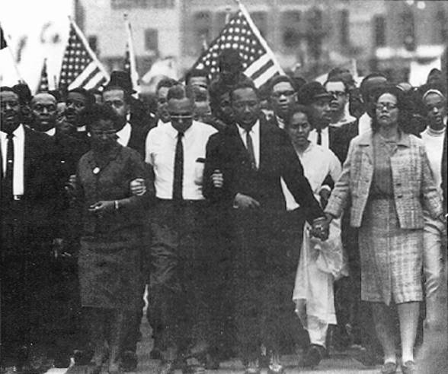
Question refers to the photograph below of the 1963 March on Washington. Bruce Davidson/Magnum Photos

1. Which constitutional right are the people in the photograph exercising?

A. The right to privacy

B. The right to a fair trial

C. The right to freedom of religion

D. The right to freedom of assembly

2. Protests such as the one shown in the photograph are protected by United States law because the protestors are

A. over 21 years of age

B. behaving peacefully

C. not calling for major changes in the American system

D. both men and women

3. What are two specific ways in which marches and demonstrations such as the one illustrated can achieve political goals?
1)
________________________________________________________________________________

________________________________________________________________________________

________________________________________________________________________________

2)
________________________________________________________________________________

________________________________________________________________________________

________________________________________________________________________________

Questions 4-7 refer to the passage below from the Declaration of Independence.

We hold these truths to be self-evident, that all men are created equal, that they are endowed by their Creator with certain unalienable Rights, that among these are Life, Liberty and the pursuit of Happiness. That to secure these rights, Governments are instituted among Men, deriving their just powers from the consent of the governed, that whenever any Form of Government becomes destructive of these ends, it is the Right of the People to alter or to abolish it, and to institute new Government, laying its foundation on such principles and organizing its powers in such form, as to them shall seem most likely to effect their Safety and Happiness.

4. According to the passage, the most important purpose of government is to protect

A. people from harm

B. the church
C. the truth

D. people's rights

5. Which statement best summarizes the main point being made in the passage?

A. The people should be in control of their own government.

B. The church should help governments determine what is right.

C. The main function of government is to keep people happy.

D. Governments need to be changed regularly to keep them from becoming unjust

6. The Declaration of Independence was written to

A. appeal to other countries for help in fighting Great Britain

B. convince Great Britain to repeal the Stamp Act
C. make laws for a new form of government

D. explain why the colonies were breaking away from Great Britain

7. According to the passage, which is more important, the individual or the government? Fill in the oval next to your choice. Then give two reasons, based on the words from the Declaration of Independence, to support your answer.

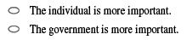

1)
________________________________________________________________________________

________________________________________________________________________________

________________________________________________________________________________

2)
________________________________________________________________________________

________________________________________________________________________________

________________________________________________________________________________

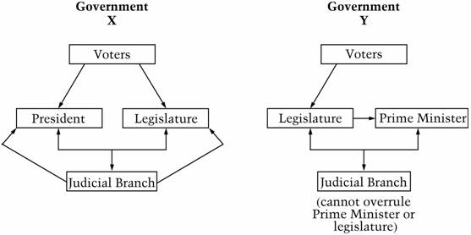
Question refers to the diagrams below.

8. Government X is different from Government Y in that in Government X the

A. executive and legislative branches are separate

B. executive, legislative, and judicial branches are all elected

C. executive branch has little real power

D. authority of the judicial branch is greater than that of the legislature

9. The diagrams represent two common forms of government. The form of government in Government Y is usually called

A. aristocratic

B. parliamentary

C. authoritarian

D. federal

10. In the United States, taxes are NOT used for

A. building churches

B. funding public libraries

C. building roads

D. taking care of parks

11. If you and other people in your community believe strongly that the United States should change its position on a conflict with another country, whom should you contact?

A. That country's ambassador to the United States

B. The United Nations

C. Your senators and congressional representative

D. The governor of your state

Questions 12 & 13 are based on the situation described below.

Teresia is a small country that has been invaded by its neighbor Corollia. The king of Teresia is a long-standing United States ally who has been living in exile since the Corollian invasion. Teresia is an important exporter of uranium; it sends most of its supply to members of the European Union. The king appeals to the United States and the United Nations for military help in driving Corollia from his country.

12. What official argument would members of the United Nations be most likely to make for supporting military efforts against Corollia?

A. The stability of the international system depends on countries maintaining their current forms of government.

B. The United Nations and the European Union should control the mining of uranium worldwide.
C. The stability of the international system depends on absolute respect for national borders and sovereignty.

D. Countries such as the United States should become the main judges in all international disputes.

13. Identify two pieces of information NOT given above that you would need before you could decide whether or not the United States military should help Teresia. Explain why each piece of information would be important.

1)
________________________________________________________________________________

________________________________________________________________________________

________________________________________________________________________________

________________________________________________________________________________

2)
________________________________________________________________________________

________________________________________________________________________________

________________________________________________________________________________

________________________________________________________________________________

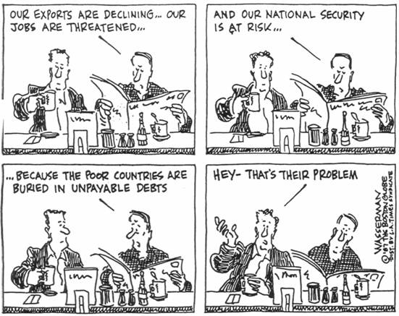
Question 14 refers to the cartoon. Copyright 1987 Tribune Media Services, Inc. All rights reserved. Reprinted by permission.

14. What is the main point of the cartoon?

A. The United States government should lend more money to poorer countries.

B. The United States military should protect poorer countries.

C. Domestic and foreign policy are related.

D. Citizens are well informed about political issues.

Questions 15 & 16 refer to the passage below.

Over recent years the National Rifle Association (NRA) has played an important role in politics. It has a large number of members, whose voting strength tends to impress legislators. It holds regular meetings with members of Congress and federal bureaucrats. It gives campaign contributions to candidates who oppose gun control and spends money directly to oppose gun control supporters.

15. The meetings with legislators and bureaucrats described in the passage are known as

A. lobbying

B. vetoing

C. filibustering

D. gerrymandering

16. Which of the following would the National Rifle Association (NRA) probably cite in support of its position on gun control?

A. The Declaration of Independence

B. The Preamble to the Constitution

C. The First Amendment to the Constitution

D. The Second Amendment to the Constitution

17. Franklin D. Roosevelt won four presidential elections between 1932 and 1944. Why could he not have won four elections today?

A. The Constitution has been amended to prevent people over the age of 70 from serving as President.

B. The Constitution has been amended to prevent people from being elected to more than two terms as President.
C. Roosevelt's political party no longer exists.

D. The electoral college system makes it difficult for candidates to serve more than two terms as President.

18. Which of the following does the national (federal) government of the United States do that state and local governments do not?

A. Run public schools

B. Print money

C. Remove state governors from office

D. Choose members of city councils

19. The Constitution requires that the President's nominations to the Supreme Court be approved by the Senate. This is an example of

A. legislative supremacy

B. federalism

C. checks and balances

D. judicial review

