- Item Detail for Question 1

Solution:
Sample Correct Response:

Correct Oval: Barbara

Explanation: Barbara’s claim is correct because the solution set to question A is and the solution set to question B is the set of all real numbers.

OR

There are values for x , such as , that satisfy question B, but do not satisfy question A.

OR

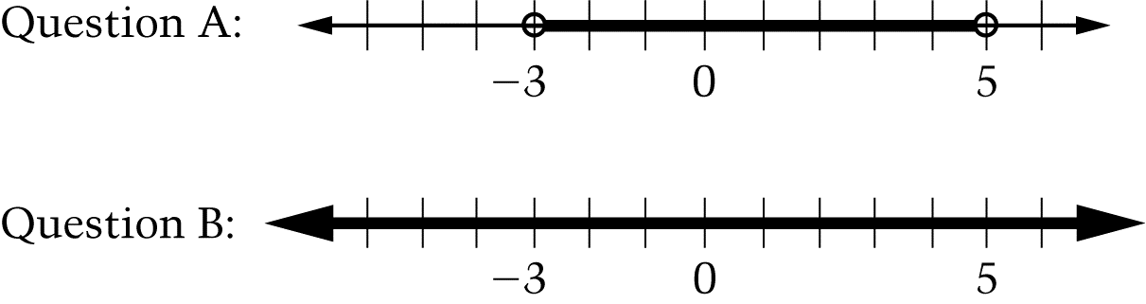

Notes:

For Question B: If is a real number, what are all the values of for which?

The answer for Question B when using an inclusive OR is the set of all real numbers (i.e., all numbers that are greater than and also all numbers that are less than 5; this the numbers between and 5).

The answer for Question B when using an exclusive OR is the set of all real numbers that are either greater than or less than 5, of the numbers between and 5 (i.e., exclusive of the numbers which are common to both sets).

Score and Description

Correct - Correct oval filled in with acceptable explanation

Partial 1 - Correct oval filled in with incomplete or partially correct explanation

Partial 2 - Neither oval or incorrect oval filled in with acceptable explanation supporting Barbaras claim

Partial 3 - Correct oval filled in with explanation that treats the or in Question B as an exclusive or

Incorrect 1 - Correct oval filled in with incorrect or no explanation

Incorrect 2 - Other incorrect responses

- Item Detail for Question 2 - The correct answer is: D. 90

- Item Detail for Question 3 - The correct answer is: B. 45

- Item Detail for Question 4

Solution:
Sample Correct Response:

Answer: cm² or equivalent

Solution:

The base of the triangle is segment FG with length 8 (given).

The height of the triangle is segment ED , which is the hypotenuse of triangle EBD , an isosceles right triangle with legs of length 3 (the lengths of BE and BD are given).

Using the Pythagorean Theorem,

Therefore,

Area

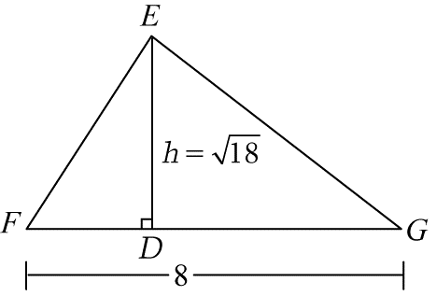

NOTE: To be acceptable, a solution must indicate the height and show how the area was calculated.

_____________________________________________________________________________________________________

Score and Description

Extended - Answer of with acceptable solution

Satisfactory - Answer of with incomplete solution, partially correct solution, no solution, or imprecise notation

Partial - Answer is not , but correct process is used

Minimal - Answer of 24 with work showing

Incorrect - Incorrect response

- Item Detail for Question 5 - The correct answer is: D. C38 = B38 * C3 * F3

- Item Detail for Question 6

Solution:
Sample Correct Response:

OR

SUM

OR

SUM

OR

Mary should add the values in cells C6 through C57.

Score and Description

Correct - Correct formula or description

Incorrect - Incorrect response

- Item Detail for Question 7 - The correct answer is: B. 71 inches

- Item Detail for Question 8 - The correct answer is: B.

- Item Detail for Question 9 - The correct answer is: B. 64

- Item Detail for Question 10

Solution:
Sample Correct Response:

Solution:

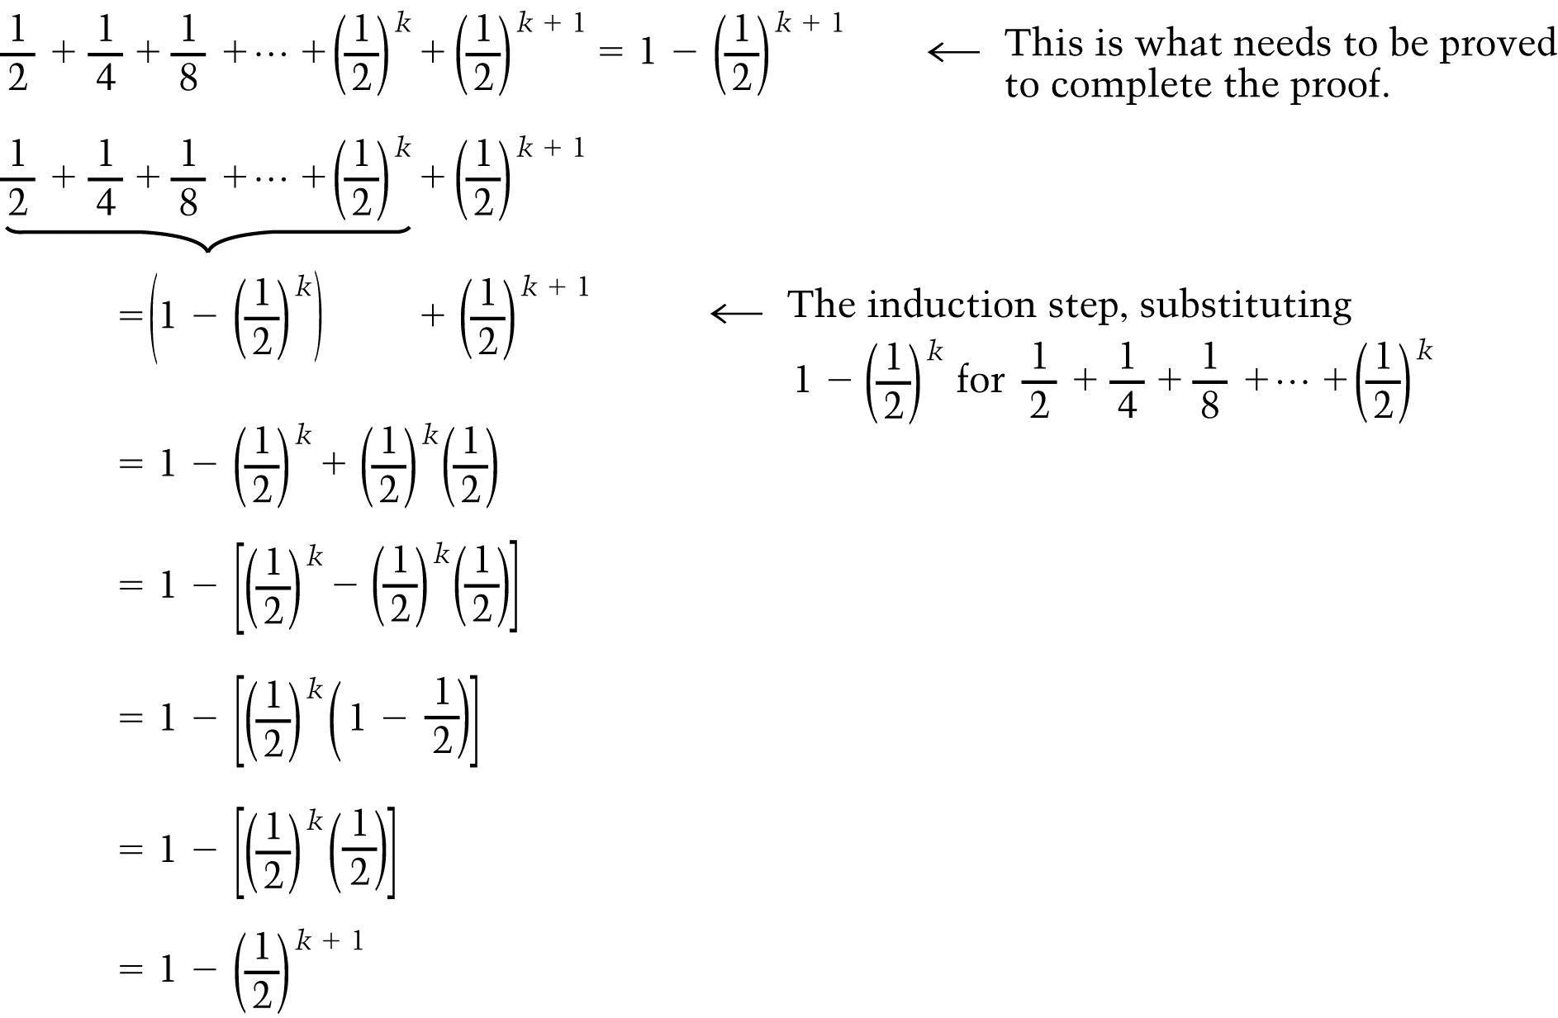

_____________________________________________________________________________________________________
Score and Description

Satisfactory - Proof completed correctly

Partial - Response shows the induction step, but does not correctly complete proof

Minimal - Response only indicates what needs to be proved to complete the proof

Incorrect - Incorrect response

