- Item Detail for Question 1 - No student responses are available for this question.

- Item Detail for Question 2

Full Comprehension - Student Response
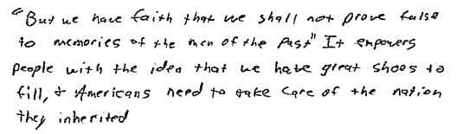
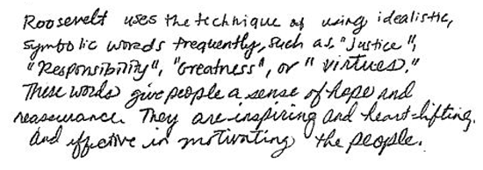

-------------------------------------------------------------------------------------------------------------------------------------------------------------------------The first response identifies Roosevelt's use of vocabulary as a persuasive strategy and explains how these word choices have emotional appeal for the audience. The second response identifies Roosevelt's specific reference to the past and explains its effectiveness as an appeal to one's sense of patriotism and commitment.

Partial Comprehension - Student Response
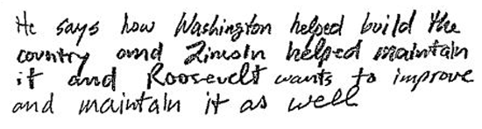
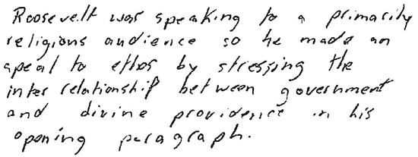

-------------------------------------------------------------------------------------------------------------------------------------------------------------------------The first response identifies a persuasive strategy Roosevelt used, but does not explain how it is effective. The second response provides Roosevelt's reference to notable persons, but no explanation of how this is effective as a persuasive strategy is provided.

Little or No Comprehension - Student Response
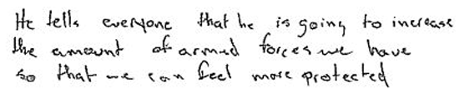
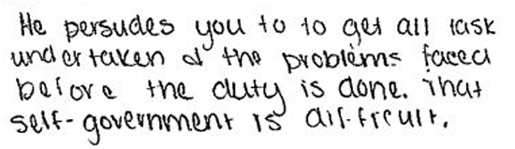

-------------------------------------------------------------------------------------------------------------------------------------------------------------------------The first response presents non-contextual phrases from page 4 with no explanation of a persuasive strategy. The second response provides an idea which is not mentioned in Roosevelt's speech.

- Item Detail for Question 3 - No student responses are available for this question.

- Item Detail for Question 4 - No student responses are available for this question.

- Item Detail for Question 5

Extensive - Student Response
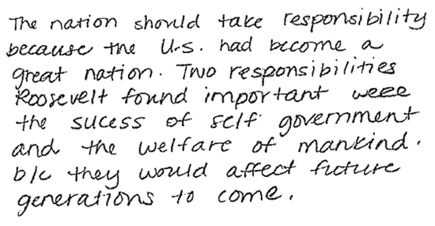
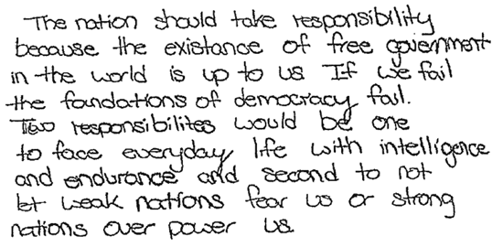

-------------------------------------------------------------------------------------------------------------------------------------------------------------------------Both responses explain why Roosevelt believed the nation should take responsibility: the first response refers to Roosevelt's belief that the United States must uphold the foundations of democratic free government; and the reason why in the second response is that the United States has become a great nation. Each response also specifies two distinct responsibilities that Roosevelt mentions as important in his address.

Essential - Student Response
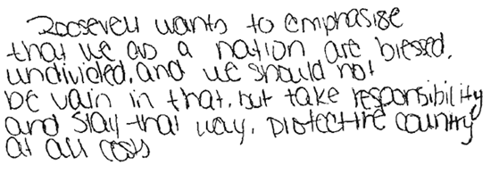
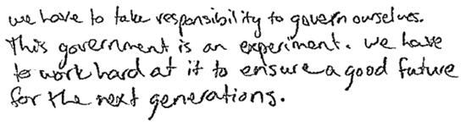
-------------------------------------------------------------------------------------------------------------------------------------------------------------------------Each response provides a reason why Roosevelt believed the nation should take responsibility and provides one distinct responsibility that Roosevelt mentions as important in his address. The first response begins by specifying the responsibility of governing ourselves and then explains why this is important in the last sentence. The second response begins by referring to Roosevelt's belief that we should take responsibility because we are blessed as a nation and then specifies the responsibility of protecting the country.

Partial - Student Response
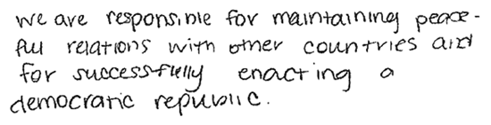
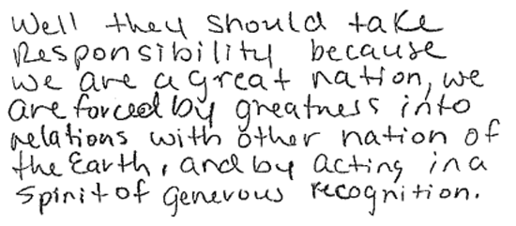

-------------------------------------------------------------------------------------------------------------------------------------------------------------------------The first response explains that Roosevelt believed taking responsibility was important because the United States is a great nation, but the rest of the response is too vague to be considered a duty or responsibility. The second response provides two responsibilities but does not include an explanation as to why Roosevelt felt taking the responsibility was important.

Unsatisfactory - Student Response
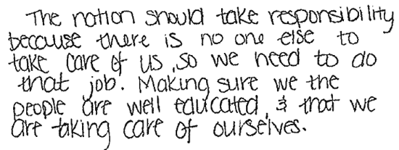
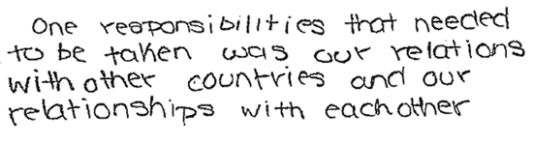
-------------------------------------------------------------------------------------------------------------------------------------------------------------------------
The first response provides a vague generalization. The second response provides a personal opinion. Neither response reflects understanding of the reasons and responsibilities expressed in the text of Roosevelt's address.

- Item Detail for Question 6 - No student responses are available for this question.

- Item Detail for Question 7 - No student responses are available for this question.

- Item Detail for Question 8

Full Comprehension - Student Response
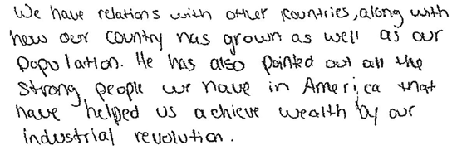
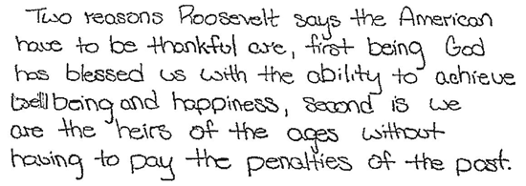

-------------------------------------------------------------------------------------------------------------------------------------------------------------------------

Both responses provide two specific reasons from Roosevelt's address as to why the American people at that time could be thankful. The first response indicates that Americans had the ability to achieve a comfortable standard of living and were free from the constraints of past civilizations. The second response indicates that the country's populace had grown and that citizens had reaped financial rewards from industry.

Partial Comprehension - Student Response
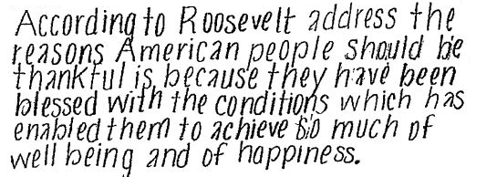
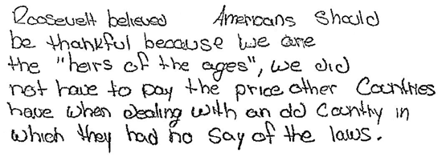

-------------------------------------------------------------------------------------------------------------------------------------------------------------------------Both responses provide one reason from Roosevelt's address as to why Americans should have been thankful. The first response refers to the unprecedented democratic freedoms Americans enjoyed; the second response refers to the conditions which enabled them to achieve well-being and happiness.
Little or No Comprehension - Student Response
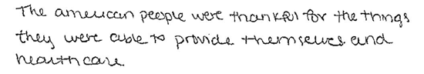
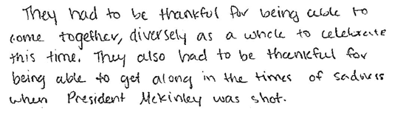
-------------------------------------------------------------------------------------------------------------------------------------------------------------------------The first response provides irrelevant information from the text box and does not include a reason given by Roosevelt. The second response provides only a personal opinion, not a reason given in Roosevelt's address.

- Item Detail for Question 9

Full Comprehension - Student Response
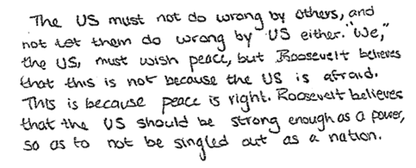
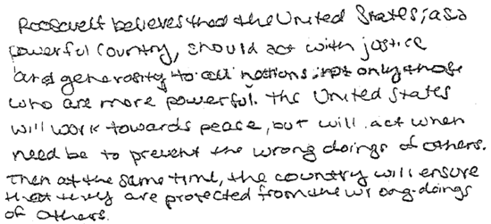

-------------------------------------------------------------------------------------------------------------------------------------------------------------------------Both responses correctly recognize Roosevelt's core view of the importance of reciprocity among nations. The first response includes details about the United States' power and the prevention of wrongdoing to other countries as well as to our own. The second response elaborates on the idea of a just peace.

Partial Comprehension - Student Response
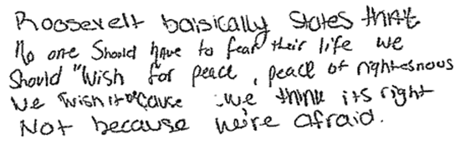
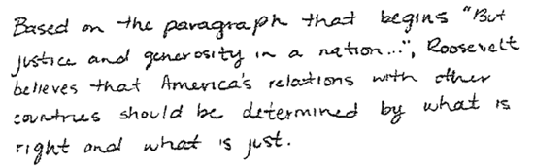

-------------------------------------------------------------------------------------------------------------------------------------------------------------------------The first response provides one aspect of Roosevelt's view: the need for the United States to be just. The second response refers to a relevant idea about peace in the paragraph but does not interpret its meaning in the context of Roosevelt's view.

Little or No Comprehension - Student Response
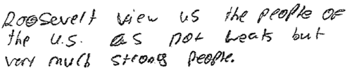
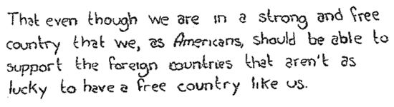
-------------------------------------------------------------------------------------------------------------------------------------------------------------------------The first response provides a personal opinion that is not based on information in the paragraph. The second response provides a correct detail from the paragraph that does not answer the question.

- Item Detail for Question 10 - No student responses are available for this question.

