- Item Detail for Question 1

No student responses are available for this question.

- Item Detail for Question 2

No student responses are available for this question.

- Item Detail for Question 3

No student responses are available for this question.

- Item Detail for Question 4

No student responses are available for this question.

- Item Detail for Question 5

- Complete - Student Response
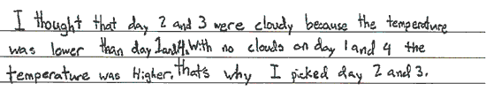

-------------------------------------------------------------------------------------------------------------------------------------------------------------------------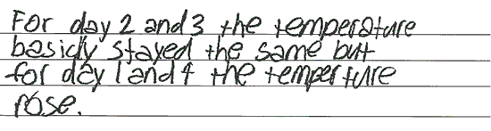

-------------------------------------------------------------------------------------------------------------------------------------------------------------------------Both responses select (B) and (C) and correctly relate differences in the temperature data to the amount of cloud cover for all four days.

Partial - Student Response
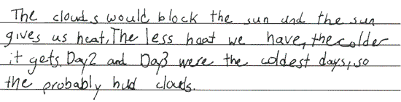

-------------------------------------------------------------------------------------------------------------------------------------------------------------------------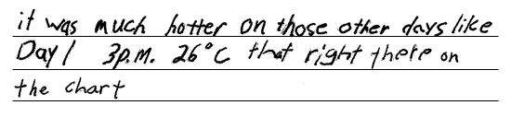

-------------------------------------------------------------------------------------------------------------------------------------------------------------------------The first response selects (B) and (C) and correctly relates the temperature data to the weather for two of the four days. The second response selects (C) and correctly relates the temperature data to the weather for one of the four days.

Unsatisfactory/Incorrect - Student Response
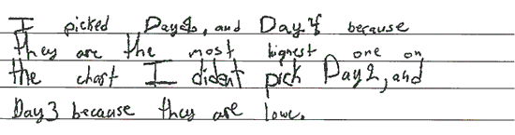

-------------------------------------------------------------------------------------------------------------------------------------------------------------------------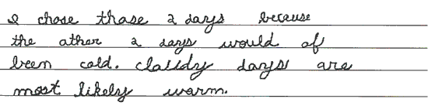

-------------------------------------------------------------------------------------------------------------------------------------------------------------------------The first response selects (A) and (D) with an incorrect explanation. The second response selects (A) and (B) with an incorrect explanation.

- Item Detail for Question 6

No student responses are available for this question.

- Item Detail for Question 7

Complete - Student Response
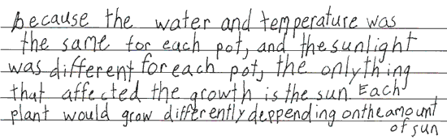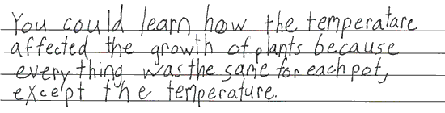

-------------------------------------------------------------------------------------------------------------------------------------------------------------------------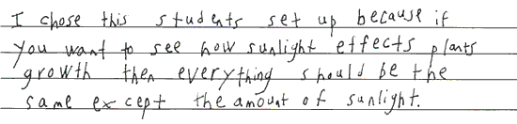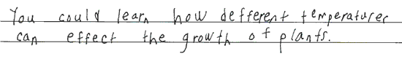

-------------------------------------------------------------------------------------------------------------------------------------------------------------------------Both responses select (B) and indicate that all variables were kept constant except the amount of sunlight which was varied. Both responses recognize what can be learned from the setup not chosen.

Essential - Student Response
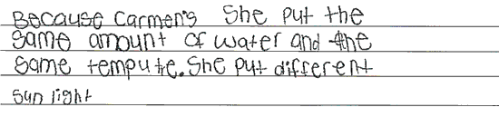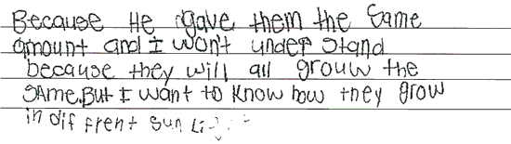

-------------------------------------------------------------------------------------------------------------------------------------------------------------------------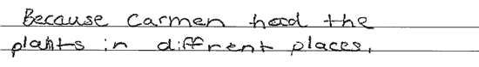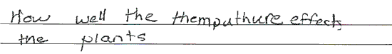

-------------------------------------------------------------------------------------------------------------------------------------------------------------------------Both responses select (B). The first response recognizes which variables were kept constant and which variable was varied. The second response recognizes what can be learned from the setup not chosen.

Partial - Student Response
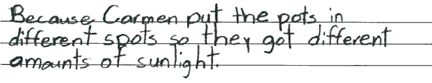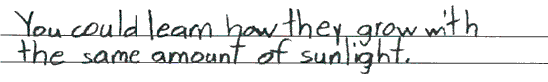

-------------------------------------------------------------------------------------------------------------------------------------------------------------------------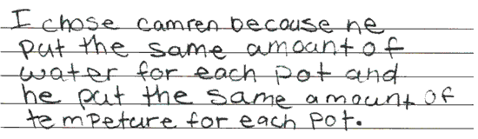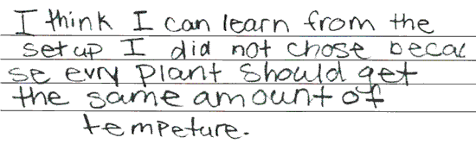

-------------------------------------------------------------------------------------------------------------------------------------------------------------------------Both responses select (B). The first response recognizes which variable was varied. The second response recognizes which variables were kept constant.

Unsatisfactory/Incorrect - Student Response
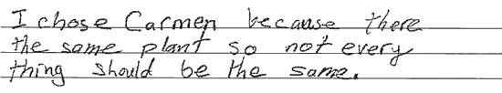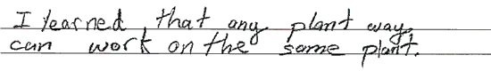

-------------------------------------------------------------------------------------------------------------------------------------------------------------------------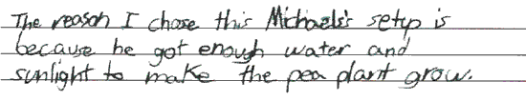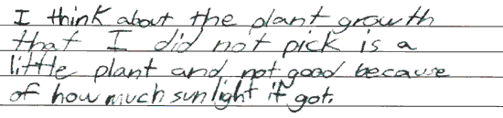

-------------------------------------------------------------------------------------------------------------------------------------------------------------------------The first response selects (B) with an incorrect explanation. The second response selects (A) with an incorrect explanation.

Item Detail for Question 8

Complete - Student Response
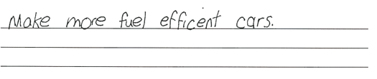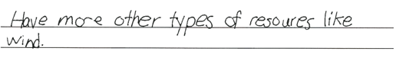

-------------------------------------------------------------------------------------------------------------------------------------------------------------------------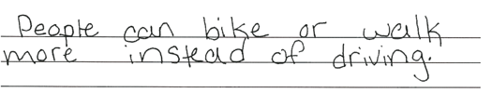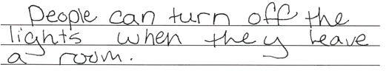

-------------------------------------------------------------------------------------------------------------------------------------------------------------------------Both responses indicate a way of using fossil fuels more efficiently and an alternative to using fossil fuels.

Partial - Student Response
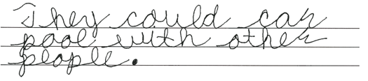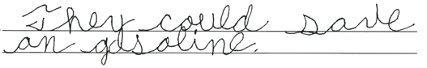

-------------------------------------------------------------------------------------------------------------------------------------------------------------------------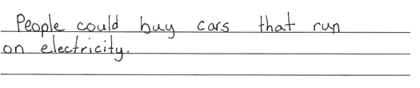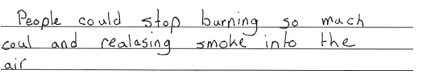

-------------------------------------------------------------------------------------------------------------------------------------------------------------------------Both responses indicate one plausible way to reduce the amount of harmful gases released. The first response indicates a more efficient use of fossil fuels. The second response indicates an alternative to using fossil fuels, but does not get credit for simply indicating to stop using a fossil fuel.

Unsatisfactory/Incorrect - Student Response
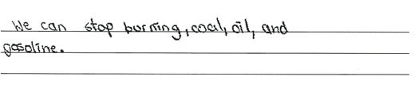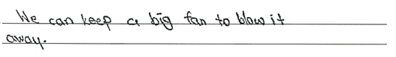

-------------------------------------------------------------------------------------------------------------------------------------------------------------------------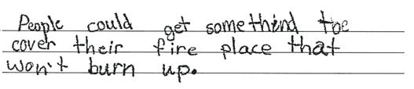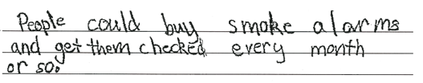

-------------------------------------------------------------------------------------------------------------------------------------------------------------------------Neither response indicates a plausible way to reduce the amount of harmful gases released.

- Item Detail for Question 9

No student responses are available for this question.

- Item Detail for Question 10

Complete - Student Response
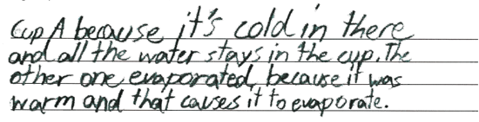

-------------------------------------------------------------------------------------------------------------------------------------------------------------------------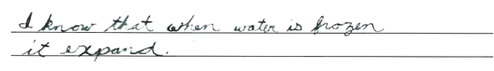

-------------------------------------------------------------------------------------------------------------------------------------------------------------------------Both responses select (A) and provide distinct explanations. The first response claims a faster rate of evaporation at a warmer temperature. The second response indicates that water expands upon freezing.

Partial - Student Response
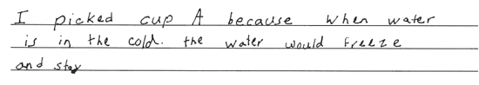

-------------------------------------------------------------------------------------------------------------------------------------------------------------------------

-------------------------------------------------------------------------------------------------------------------------------------------------------------------------The first response selects (A) and indicates a reason for Cup A having more water. The second response selects (B) and indicates a means by which water leaves the cup.

Unsatisfactory/Incorrect - Student Response
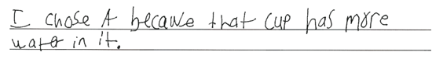

-------------------------------------------------------------------------------------------------------------------------------------------------------------------------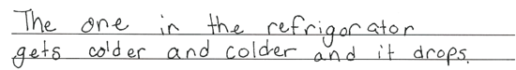

-------------------------------------------------------------------------------------------------------------------------------------------------------------------------The first response selects (A) and only describes what is shown in the diagram. The second response selects (B) and only mentions temperature conditions.

- Item Detail for Question 11

Complete - Student Response
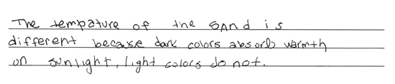

-------------------------------------------------------------------------------------------------------------------------------------------------------------------------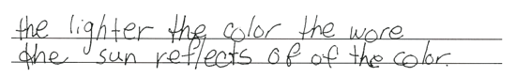

-------------------------------------------------------------------------------------------------------------------------------------------------------------------------The first response correctly relates darker colors to greater amount of sunlight absorbed. The second response correctly relates lighter colors to greater amount of sunlight reflected.
Partial - Student Response
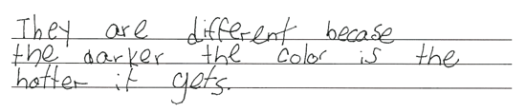

-------------------------------------------------------------------------------------------------------------------------------------------------------------------------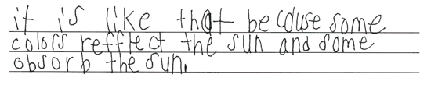

-------------------------------------------------------------------------------------------------------------------------------------------------------------------------The first response correctly relates the differences in temperatures of the sand in the containers to the differences in their colors, but does not address absorption or reflection of sunlight. The second response correctly relates the differences in colors of the sand in the containers to their abilities to absorb or reflect sunlight, but does not address temperature of sand.

Unsatisfactory/Incorrect - Student Response
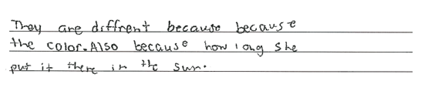

-------------------------------------------------------------------------------------------------------------------------------------------------------------------------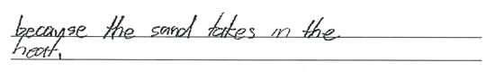

-------------------------------------------------------------------------------------------------------------------------------------------------------------------------The responses mention color and heat respectively, but do not address temperature or sunlight absorption.

- Item Detail for Question 12

No student responses are available for this question.

- Item Detail for Question 13

Complete - Student Response
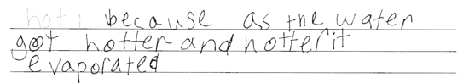

-------------------------------------------------------------------------------------------------------------------------------------------------------------------------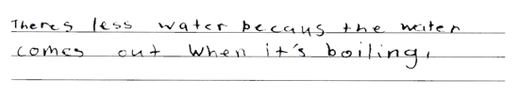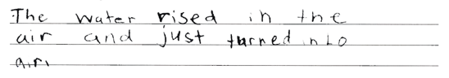

-------------------------------------------------------------------------------------------------------------------------------------------------------------------------The first response addresses evaporation; the second response addresses boiling. Both responses correctly indicate where the water went.

Partial - Student Response
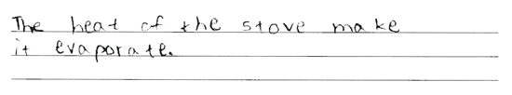

-------------------------------------------------------------------------------------------------------------------------------------------------------------------------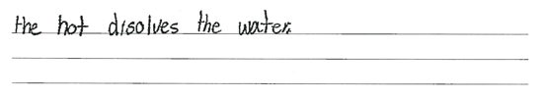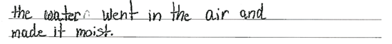

-------------------------------------------------------------------------------------------------------------------------------------------------------------------------The first response indicates evaporation; the second response indicates where the water went.

Unsatisfactory/Incorrect - Student Response
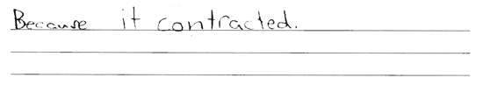

-------------------------------------------------------------------------------------------------------------------------------------------------------------------------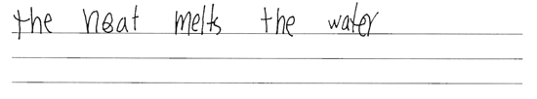

-------------------------------------------------------------------------------------------------------------------------------------------------------------------------Both responses indicate that heat played a factor but show misconceptions of what happened to the heated water.

- Item Detail for Question 14

No student responses are available for this question.

- Item Detail for Question 15

No student responses are available for this question.

- Item Detail for Question 16

No student responses are available for this question.

