Name _________________________________________________

1. Kelly is playing outside. She is wearing shorts and a T-shirt. Which is most likely the temperature outside?

A. 0 F

B. 32 F

C. 85 F

D. 212 F

2. Part of a closed shape is shown above. When the shape is completed, which of these could it be?
A. Pentagon

B. Rectangle

C. Square

D. Triangle

3. A bag of potatoes weighs 12.4 pounds. Which of the following statements is true?

A. There are between 1 and 2 pounds of potatoes in the bag.

B. There are between 12 and 13 pounds of potatoes in the bag.

C. There are between 124 and 125 pounds of potatoes in the bag.

D. There are between 1,246 and 1,247 pounds of potatoes in the bag.

4. Tim, Bob, and Molly joined a club between March and July. Tim joined the club after Bob. Molly joined the club before Bob. Which time line shows the order in which they joined the club?

A. 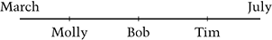

B. 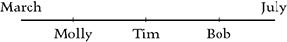

C. 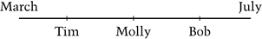

D. 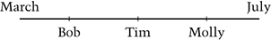

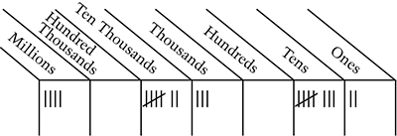
5. Which number does the diagram represent?

A. 4,703,082

B. 4,073,082

C. 473,820

D. 407,382

6. What one additional piece of information is needed to find how many minutes Louisa was gone from her house?

Louisa walked for 15 minutes from her house to Mary’s house. She spent 25 minutes at Marys house. She walked 10 minutes to the store. She bought groceries at the store. She walked 10 more minutes to get home.

A. What time Louisa left home

B. How fast Louisa walked

C. How far Louisa lives from Mary

D. How long Louisa was at the store

7. In the diagram, what is the relationship between the number of s and the number of s?
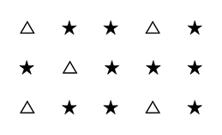
A. For every 1 , there are 2 s

B. For every 1 , there are 10 s

C. For every 2 s, there is 1

D. For every 5 s, there is 1

8. A teacher drew this rectangle on a playground. Sam walked around the rectangle on the lines shown. How far did Sam walk?
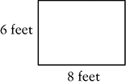
A. 14 feet

B. 20 feet

C. 28 feet

D. 48 feet

9. Kim, Les, Mario, and Nina each had a string 10 feet long. Kim cut hers into fifths. Les cut his into fourths. Mario cut his into sixths. Nina cut hers into thirds. After the cuts were made, who had the longest pieces of string?

A. Kim

B. Les

C. Mario

D. Nina

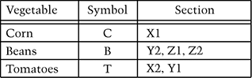

10. Andrea is planning a garden. She divided her garden into sections. Use the information in the chart above to complete the grid below. In each section of the grid, write the symbol C, B, or T to show where each vegetable goes.
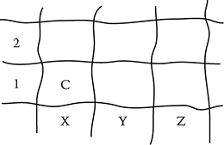

11. On April 1, Larry’s puppy was 5 inches high. Larry measured the height of his puppy three more times during the year.

May 1: inches August 1: 10 inches December 1: inches

On the picture of a ruler below, mark the three measurements and label the dates of the three measurements.

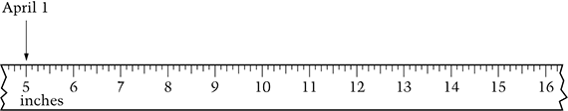

12. Which expression has the least value?

A.

B.

C.

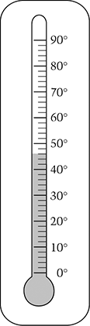
D.

13. What temperature does the thermometer show?

A.

B.

C.

D.

14. Al, Bev, and Carmen are going on a ride at the park. Only 2 people can go on the ride at a time. They can pair up 3 different ways, as shown below.

Al and Bev
Al and Carmen
Bev and Carmen

Derek decides to join the group. How many different ways can the 4 students pair up?

Answer: __________________

Show your work or explain how you got your answer.

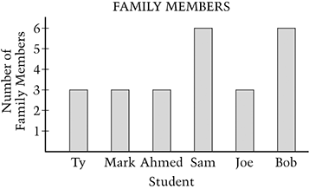

15. The graph above shows the number of family members for six students. Which graph below is the best summary of the data?

A. 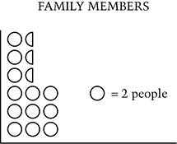

B. 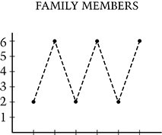

C. 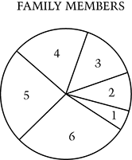

D. 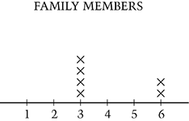

16. If the pattern shown continues, what is the first fraction in the pattern that will be greater than 1?

A.
B.

C.

D.

