Name _________________________________________________

1. Which animal lives in water when very young and then lives on land as an adult?

A. 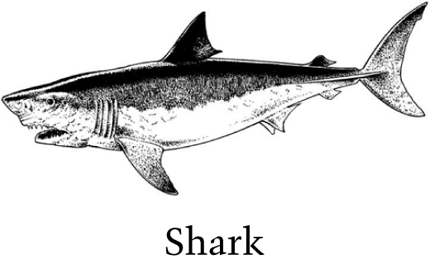

B. 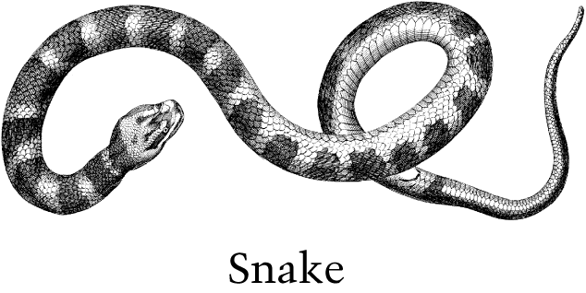

C. 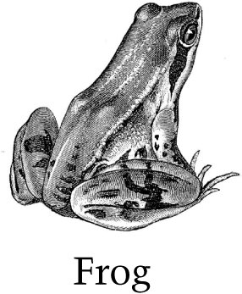

D. 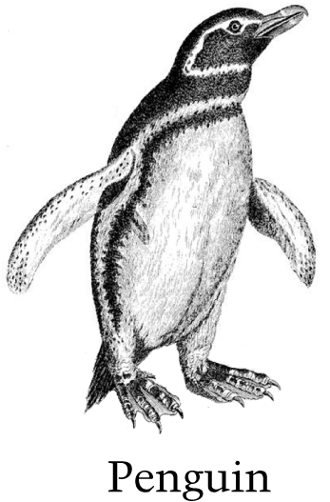

2. Which tool is used to measure how much rain falls during a storm?

A. 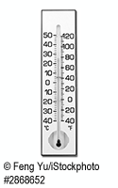

B. 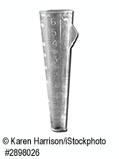

C. 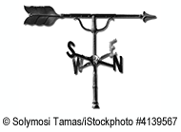

D. 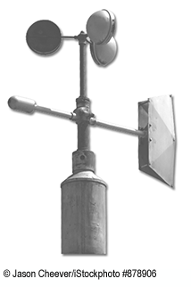

Questions 3 & 4 refers to a bird called a warbler shown below.
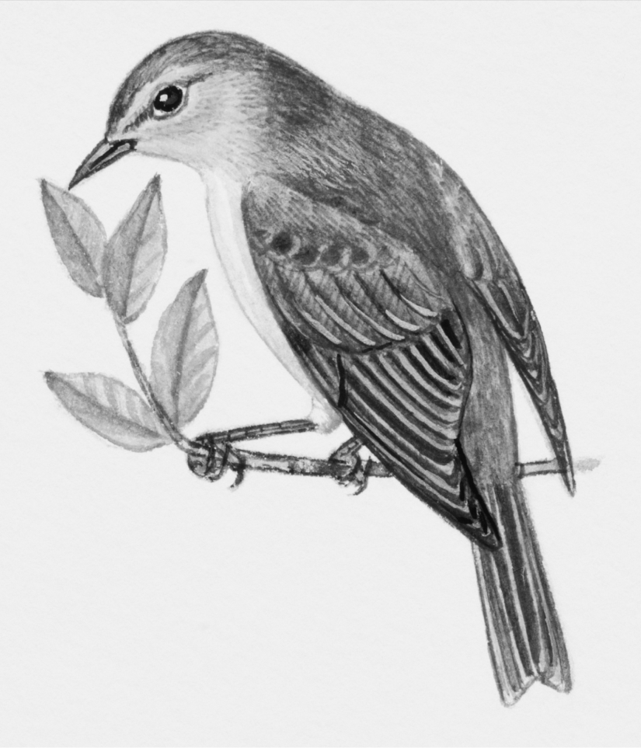

Scientists study warblers by placing small metal bands on the birds' legs. A number is stamped on the band. This number lets scientists know when and where the birds are banded.

3. A scientist studying warblers captures six of them in a net. Two of the birds have bands on their legs. What could the scientist learn from the information on the bands?

A. How much food the birds eat

B. Where the birds travel

C. Which birds are related

D. What kinds of nests the birds build

4. There are many kinds of warblers throughout the world. One kind of warbler with black-and-white feathers is often seen on tree trunks. Another kind with golden-colored feathers is often seen in fields. Which statement best explains how the color of these warblers helps them survive?

A. The color of the feathers helps the birds locate nests.

B. The color of the feathers helps to control the amount of body heat the birds lose.

C. The color of the feathers blends into the birds' surroundings and helps the birds avoid predators.

D. The color of the feathers attracts the kinds of insects the birds like to eat.

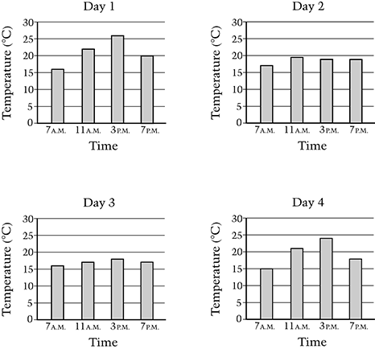
5. Grace's class measured the temperature outside four times a day for four days in a row. Their results are shown.

Based on these data, choose two days that were most likely cloudy.

- Day 1
- Day 2
- Day 3
- Day 4

Explain why you chose these two days and why you did not choose the other days. Use the data in the graphs and your science knowledge about weather in your answer.

________________________________________________________________________________

________________________________________________________________________________

________________________________________________________________________________

________________________________________________________________________________

________________________________________________________________________________

6. A thermometer shows that the outside air temperature is colder than the temperature at which water turns to ice. However, ice on the sidewalk melts. What probably caused this?

A. The air heating the sidewalk

B. The sidewalk reflecting sunlight into the air

C. The wind causing the ice on the sidewalk to melt

D. The sunlight making the sidewalk warmer than the air

7. Two students investigated the growth of pea plants. Each student had three pots. All of the pots contained the same type and amount of soil. They planted pea seeds in each pot. The students set up their investigations as shown in the table below.

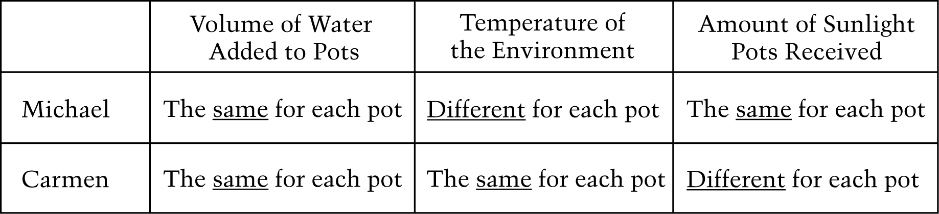

Which student had the best setup to find out how the amount of sunlight affects the growth of pea plants?

- Michael
- Carmen

Explain why you chose this student's setup.

________________________________________________________________________________

________________________________________________________________________________

________________________________________________________________________________

________________________________________________________________________________

What do you think you could learn about plant growth from the setup that you did not choose?

________________________________________________________________________________

________________________________________________________________________________

________________________________________________________________________________

________________________________________________________________________________

8. Burning coal, oil, and gasoline for energy releases gases into the atmosphere that can be harmful to the environment. What are two ways that people can reduce the amount of these gases released into the atmosphere?

________________________________________________________________________________

________________________________________________________________________________

________________________________________________________________________________

________________________________________________________________________________

________________________________________________________________________________

________________________________________________________________________________

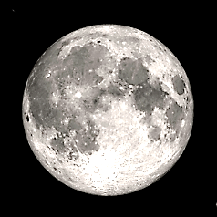
9. Jane sees the Moon in the sky one clear night. It looks like the following picture.

What will the Moon look like three nights later if there are no clouds in the sky?

A. 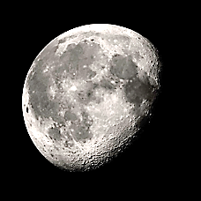

B. 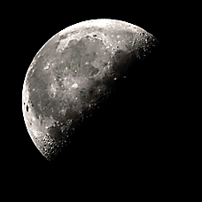

C. 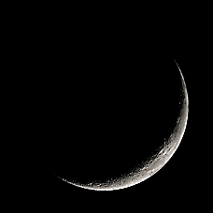

D.

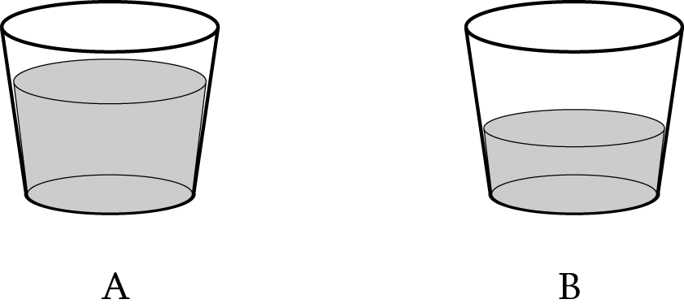
10. A student poured the same amount of water into two identical cups. He put one cup in a refrigerator and left one cup out in a warm room. Neither cup was touched. The diagram shows how much water was left in the cups two days later. Which cup was in the refrigerator? Fill in only one oval.

- Cup A
- Cup B

Explain your answer.

________________________________________________________________________________

________________________________________________________________________________

________________________________________________________________________________

________________________________________________________________________________

________________________________________________________________________________

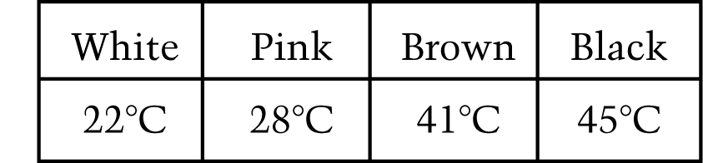
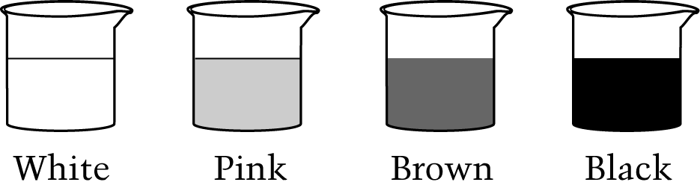
11. Janet has four identical containers. In each container there are 200 grams of a different colored sand, as shown below. All the sand is at the same temperature and has the same grain size. Janet leaves the containers out in the full sun for three hours. Then she measures the temperature of the sand in each container. Her results are shown.

Explain why the temperature of the sand in each container is different.

________________________________________________________________________________

________________________________________________________________________________

________________________________________________________________________________

________________________________________________________________________________

________________________________________________________________________________

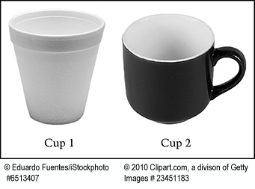
12. A student wants to know whether two cups hold the same volume of water. The two cups have different weights (masses). The student completely fills Cup 1 with water. The student wants to measure if Cup 2 holds the same volume of water.

What should the student do next to complete the measurements?

A. Completely fill Cup 2 with water and then look at the cups side by side

B. Pour half of the water from Cup 1 into Cup 2, weigh each cup and then compare their weights

C. Pour all of the water from Cup 1 into Cup 2 to see if the water completely fills Cup 2 without spilling over

D. Completely fill Cup 2 with water, weigh each filled cup, and then compare the weights

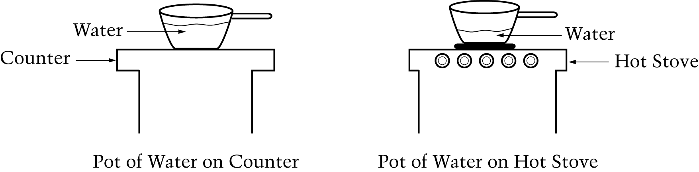
13. Anita puts the same amount of water in two pots of the same size and type. She places one pot of water on the counter and one pot of water on a hot stove. After ten minutes, Anita observes that there is less water in the pot on the hot stove than in the pot on the counter, as shown below.

Why is there less water in the pot on the hot stove?

________________________________________________________________________________

________________________________________________________________________________

________________________________________________________________________________

Where did the water go?

________________________________________________________________________________

________________________________________________________________________________

________________________________________________________________________________

14. Which animal develops inside its mother before it is born alive?

A. Butterfly

B. Cat

C. Duck

D. Frog
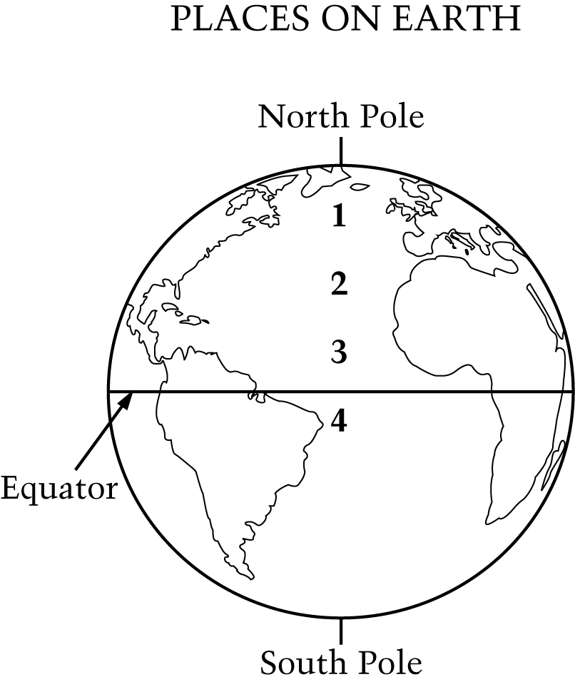
15. The diagram shows four places on Earth. Places 1, 2, 3, and 4 are all at sea level. Which place has the coldest winters?

A. 1

B. 2

C. 3

D. 4

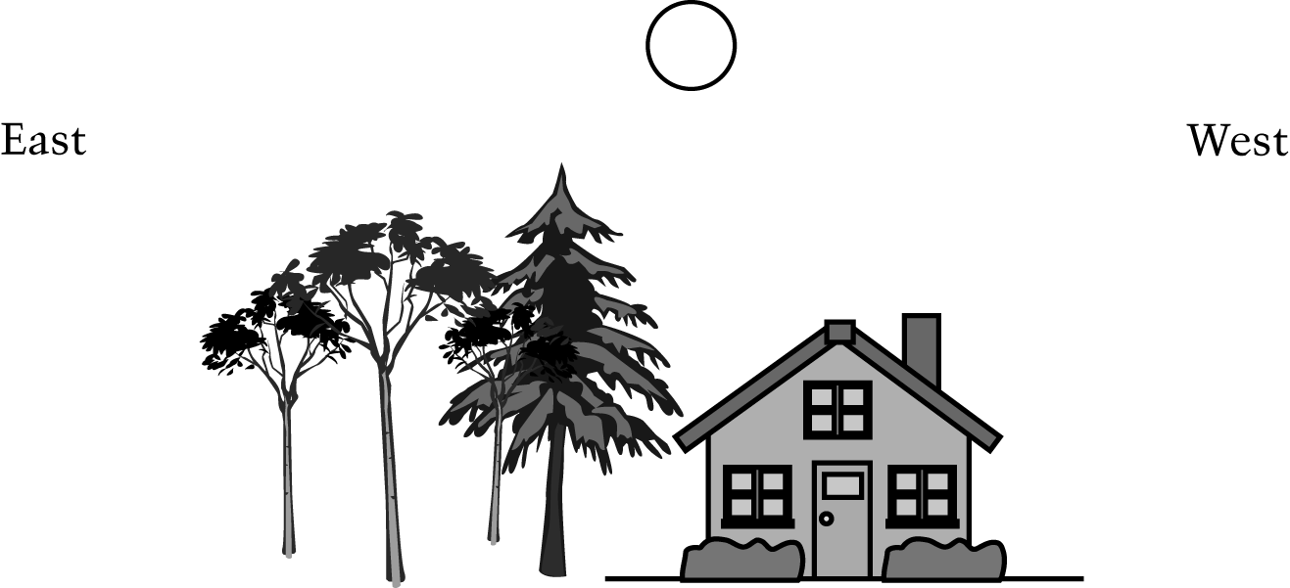
16. Jane sees the Moon in the sky one night. Look at the four diagrams below.

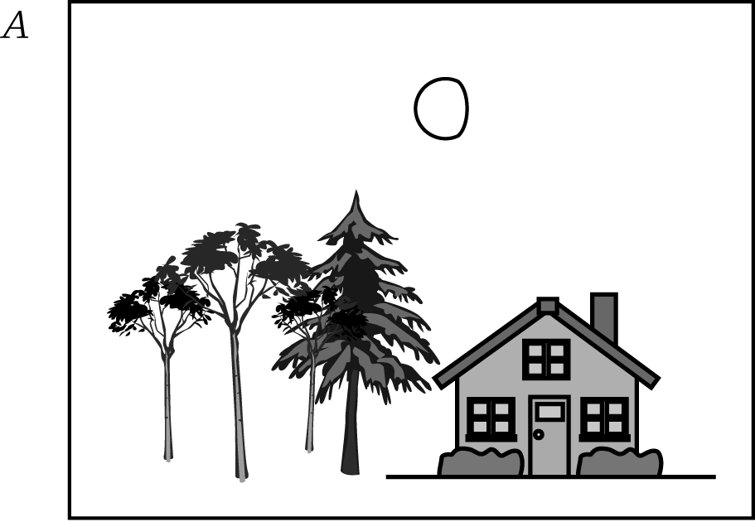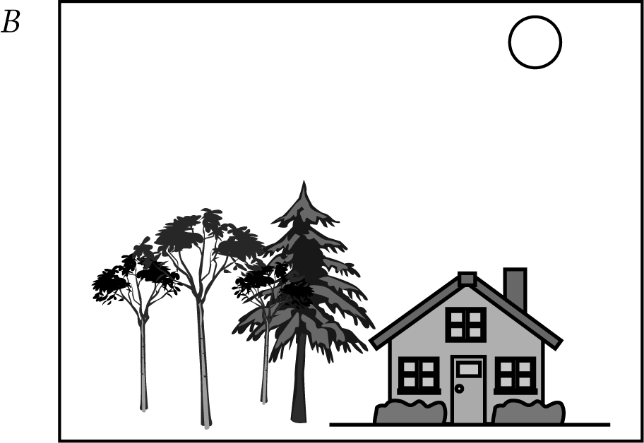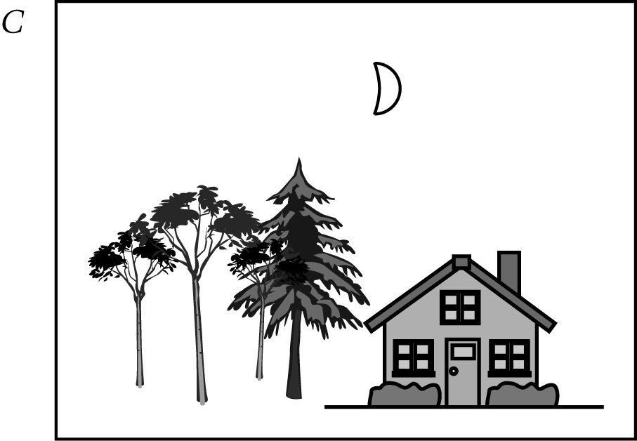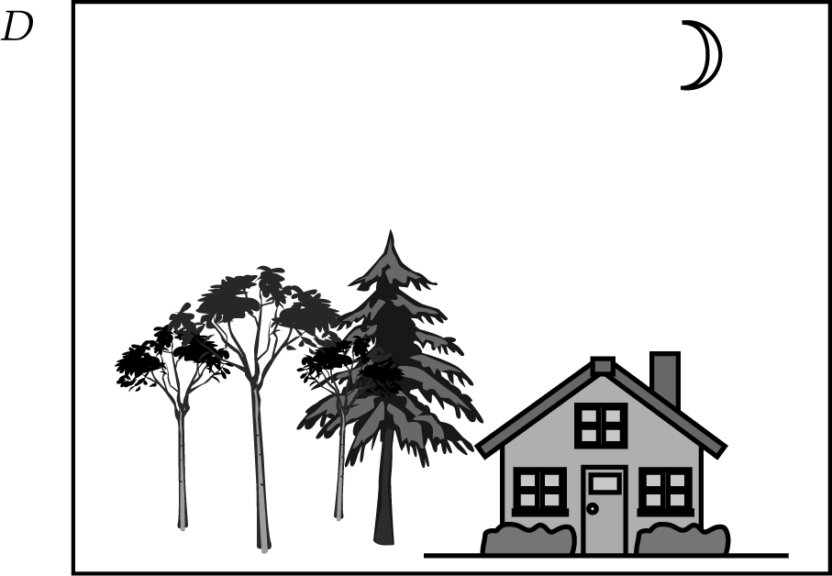

Jane stands in the same spot to observe the Moon two hours later. Which diagram shows what she will most likely see?

A. A

B. B

C. C

D. D

