Name _________________________________________________

1. Which material is the best conductor of electricity?

A. Wood

B. Metal

C. Stone

D. Plastic

2. Roger poured water over a pile of sand. Some of the sand washed away. This process is similar to which of the following?

A. The eruption of a volcano

B. The erosion of the walls of a canyon

C. The uplifting of mountain ranges
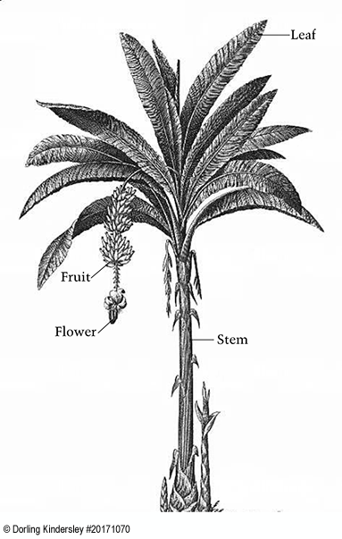
D. The forming of dunes or mounds in a desert

3. Look at the banana plant shown below. What part of this plant helps it get the most light?

A. Green fruit

B. A peeling, thick stem

C. Wide, long leaves

D. Brightly colored flowers

4. When people buy groceries, they may have their groceries packed in plastic bags, paper bags, or cloth bags they bring with them. Which type of grocery bag is best to use to help protect the environment?
- Plastic
- Paper
- Cloth

Explain why your choice helps protect the environment.

________________________________________________________________________________

________________________________________________________________________________

________________________________________________________________________________

________________________________________________________________________________

________________________________________________________________________________

________________________________________________________________________________

________________________________________________________________________________

________________________________________________________________________________

5. Which statement explains why light from the Sun can warm up water in a glass?

A. Light travels very fast.

B. Light travels in straight lines.

C. Water reflects light energy.

D. Water absorbs light energy.
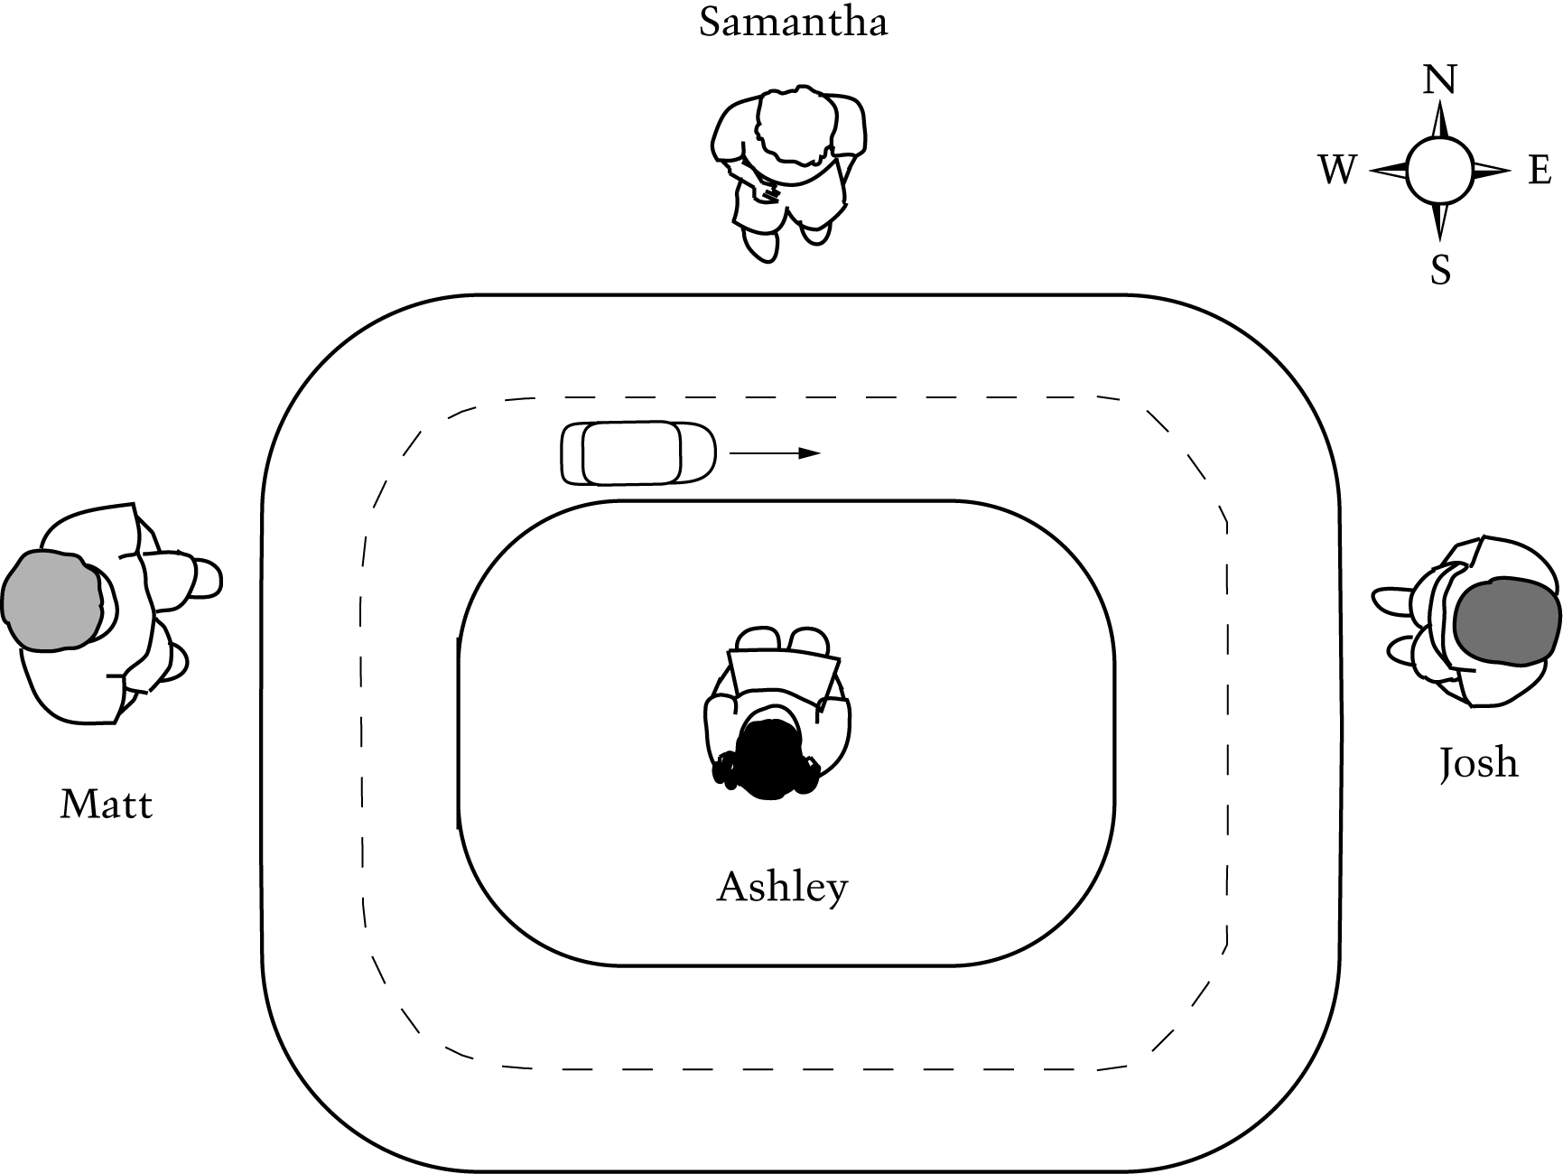

Questions 6 & 7 refer to the diagram below.

The diagram below shows the top of a toy car as it travels on a curved track. Four students, Matt, Samantha, Josh, and Ashley stand in the positions shown and watch the toy car move.

6. When the toy car is in the position shown in the diagram, which student sees the car as moving away from him or her?

A. Ashley

B. Josh

C. Matt

D. Samantha

7. When the toy car is in the position shown in the diagram, what can all four students correctly conclude about the direction in which the car is moving?

A. The car is moving left to right.

B. The car is moving right to left.

C. The car is moving east to west.

D. The car is moving west to east.

8. A bird-watcher wants to see many birds in a one-hour period. She decides to investigate which type of food will attract more birds in her backyard. She has a choice of two types of bird food.
- Sunflower seeds
- Thistle seeds

Describe a fair test the bird-watcher could conduct to help her decide which food will attract more birds.

________________________________________________________________________________

________________________________________________________________________________

________________________________________________________________________________

________________________________________________________________________________

________________________________________________________________________________

What information should the bird-watcher collect from her test to help decide which type of food attracts more birds?

________________________________________________________________________________

________________________________________________________________________________

________________________________________________________________________________

9. Jaime and Manuel visit the zoo. They see two male tigers who are brothers. Jaime points out that the fur of one of the tigers has stripes that are a darker brown than the other tiger's stripes. Manuel says the tigers cannot be brothers.

How can Jaime explain to Manuel that tigers with different-colored stripes can be brothers? In your answer, use a specific example of what you have observed about similarities and differences between people who are related.

________________________________________________________________________________

________________________________________________________________________________

________________________________________________________________________________

________________________________________________________________________________

________________________________________________________________________________

Questions 10, 11 & 12 refer to the following information.

Rafael lives near a road at the bottom of a hill. His parents are concerned that soil will wash off the hill and rocks will fall onto the road. Rafael conducts an investigation to find out if grass growing on a hillside will help stop soil erosion. He collects two samples of the same size and type of soil. One sample of soil has grass growing on it and the other does not. He places each sample of soil in a small tray.

10. For his investigation, Rafael pours the same amount of water onto both samples of soil. He uses a large tray to collect water that may flow through the soil. Which practice shows the best way for Rafael to set up this investigation?

A. 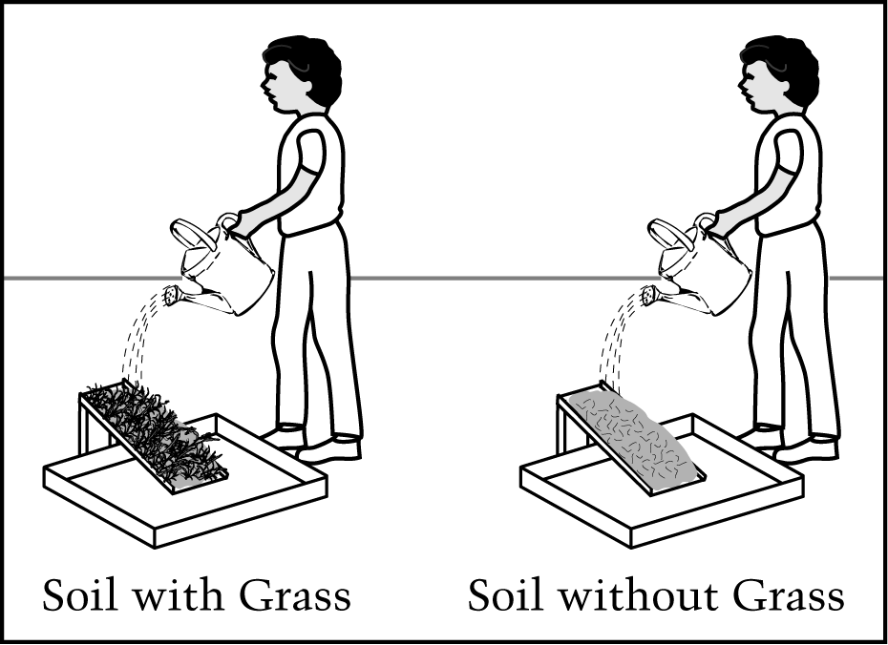

B. 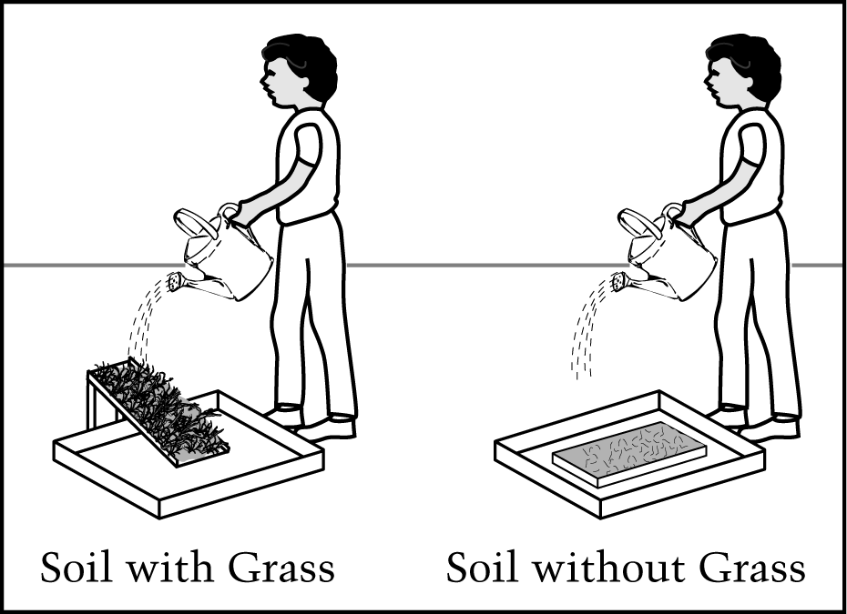
C. 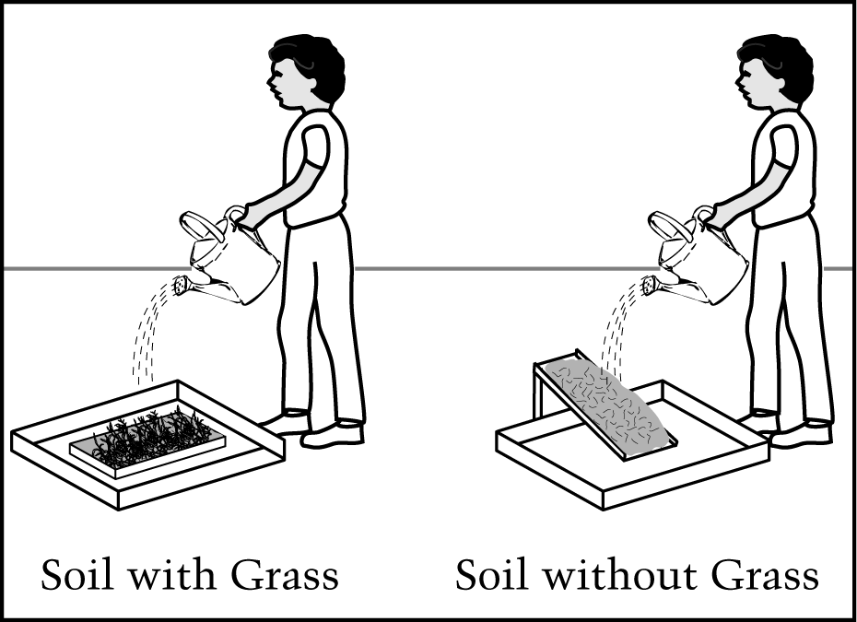

D. 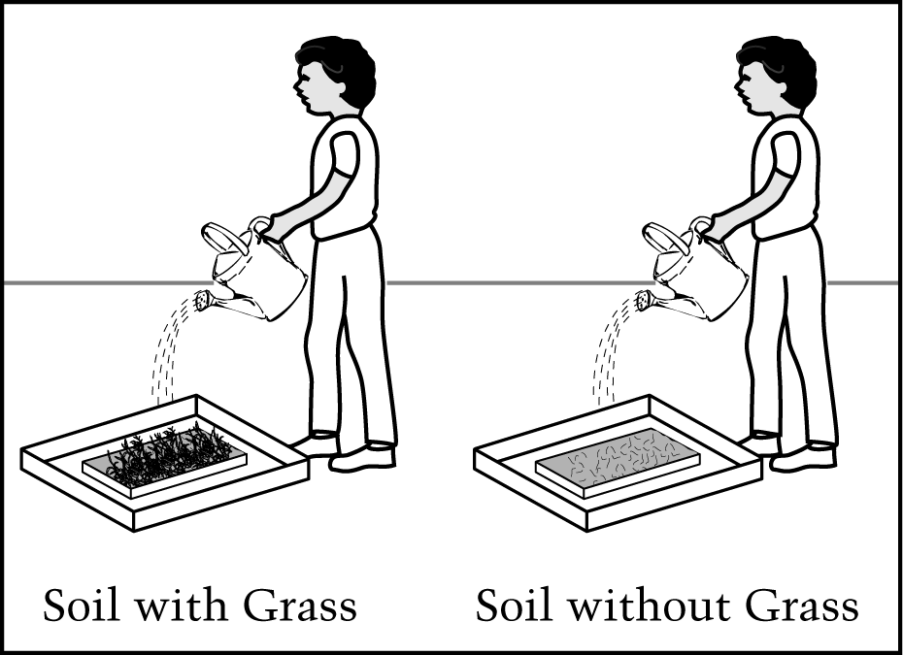

11. Rafael predicts that the water he pours on the soil without grass will carry away more soil than the water he pours on the soil with grass. Do you agree with Rafael's prediction (choose one)?
- Yes
- No

Explain why you agree or disagree.

________________________________________________________________________________

________________________________________________________________________________

________________________________________________________________________________

________________________________________________________________________________

________________________________________________________________________________

12. After pouring the water onto both pieces of soil, Rafael makes an observation. The water collected in the tray under the soil with grass looks clearer than the water collected in the tray under the soil without grass. What conclusion can Rafael make from his observation?

A. The grass helped to hold the soil in place.

B. The grass helped to move the water through the soil.

C. The soil without grass was sticky, so more water stayed in the soil.

D. The soil without grass was loose, so more water stayed in the soil.

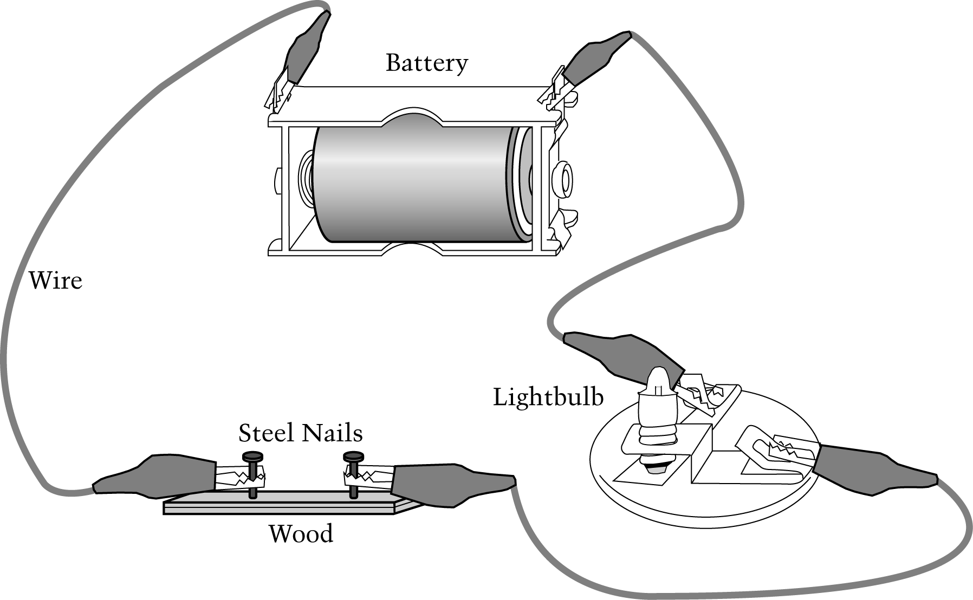
13. A student tried to connect an electrical circuit as shown. The lightbulb did not light up. What can the student do to make the lightbulb light up?

A. Connect a second battery to the first battery.

B. Replace the wires with thicker wires.

C. Replace the steel nails with aluminum nails.

D. Connect the steel nails with a short piece of wire.

14. Rafael and Sammy were playing with soccer balls on a flat tile floor. Each boy rolled a soccer ball at the same time, and the balls hit, as shown below.

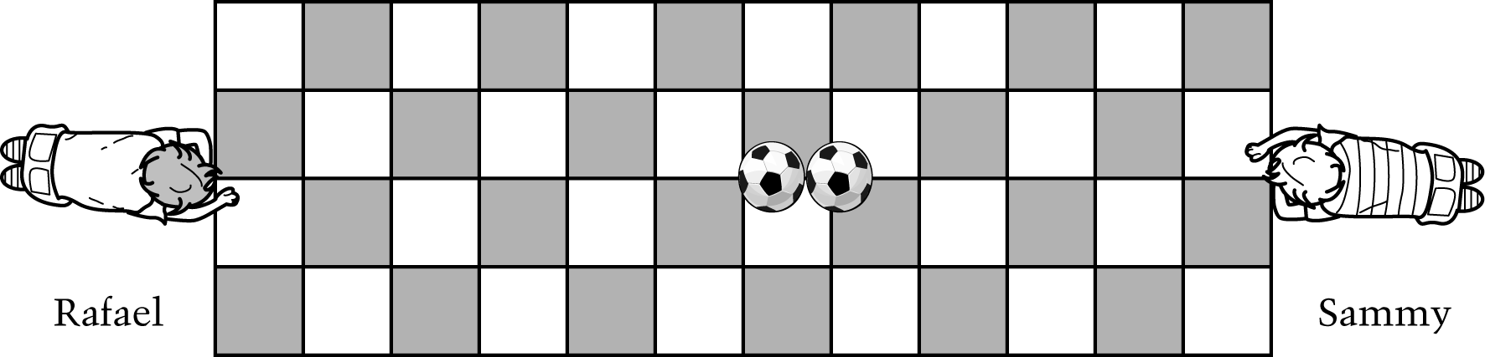

Which boy rolled his ball faster?

________________________________________________________________________________

How do you know?

________________________________________________________________________________

________________________________________________________________________________

________________________________________________________________________________

________________________________________________________________________________

________________________________________________________________________________

________________________________________________________________________________

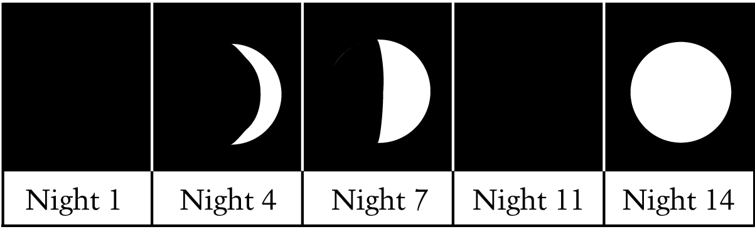
15. Jennifer drew what the Moon looked like just after sunset every third or fourth night. Her drawings for the nights she observed the Moon are shown below. On Night 11 the clouds were so thick that Jennifer could not see the Moon.

Based on the drawings for the other nights, what would Jennifer have seen on Night 11 if the sky were clear?

A.

B.

C.

D.

16. Which is an example of melting?

A. Flowing water making a rock smooth

B. A carrot becoming soft when cooked

C. Sugar mixed into tea making the tea sweet

D. Butter changing into liquid in a warm pan

