Name _________________________________________________

1. There are 26 children in Ms. Weaver's fourth-grade class. They need to decide what song to sing at their spring show. Ms. Weaver says that the majority should decide. This means that

A. all the children need to agree on one song

B. more than half the children need to agree on one song

C. Ms. Weaver will tell the children which song to pick

D. the oldest student in the class will decide on the song

2. Which of the following is most likely responsible for making sure that your community has safe drinking water?

A. The fire department

B. The county hospital

C. The attorney general

D. The local government

3. Your class at school has a new student from a country that has laws that are very different from those in the United States. Your teacher has asked you to help your new classmate learn about important rights that belong to citizens of the United States. Write down TWO important rights that people have in the United States that you think your new classmate should know about. Then tell why it is important to have each of these rights.

Right 1: ______________________________________________________

It is important to have this right because

____________________________________________________________________

____________________________________________________________________

____________________________________________________________________

____________________________________________________________________

Right 2: ______________________________________________________

It is important to have this right because

____________________________________________________________________

____________________________________________________________________

____________________________________________________________________

____________________________________________________________________
4. Rules should be fair to everyone. Which rule is unfair to a particular group in a school?

A. Only boys can sign up to play soccer.

B. Only 30 minutes will be allowed for lunch.

C. Students are expected to clean up after themselves.

D. Homework is due on Friday.

5. The money to run the government comes mostly from

A. donations

B. other countries

C. banks

D. taxes

6. Many people in the United States are very concerned about what effect unemployment has on people and society. Give two reasons why it is very important for people to have jobs and to be able to work.

1) ______________________________________________________________________

_________________________________________________________________________

_________________________________________________________________________

2) ______________________________________________________________________

_________________________________________________________________________

_________________________________________________________________________

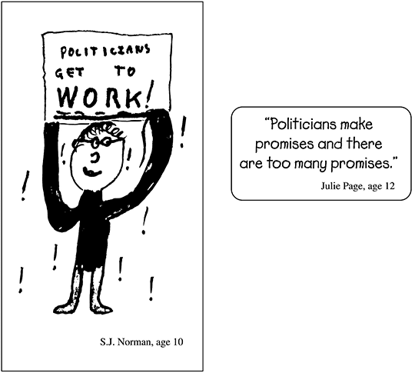

7. Look at the drawing and the statement. Both were made by children. What is the message of the drawing and of the statement?

A. There is no hope for politicians.

B. There are too many politicians.

C. Politicians talk a lot but do not do much.

D. Politicians work more than other people.

The League of Women Voters is an organization that collects and gives information to the public about elections and candidates in the United States. The League is NOT part of the United States government, and it does not represent any political party.

8. What is one reason why it is important that the League of Women Voters does not represent any political party?

A. The League can give people information that does not favor any particular candidate in an election.

B. The League can make sure that people like every candidate in an election.

C. Nongovernmental organizations are not allowed to support any political party in an election.

D. The people who belong to nongovernmental organizations usually cannot agree on which candidates to support in elections.

9. Disease, starvation, and environmental pollution are some of the problems many countries have. These problems are hard for countries to solve by themselves.

Identify two important ways countries can help one another deal with these problems.

1) _____________________________________________________________________

________________________________________________________________________

________________________________________________________________________

2) _____________________________________________________________________

________________________________________________________________________

________________________________________________________________________

Questions 10 & 11 refer to the President of the United States.

10. Who is currently the President of the United States?

A. Mike Pence

B. Donald Trump

C. Barack Obama

D. Hillary Clinton

11. Which political party does the current President belong to?

A. Green

B. Democratic

C. Republican

D. Libertarian

Questions 12, 13 & 14 refer to the article below from a local newspaper.

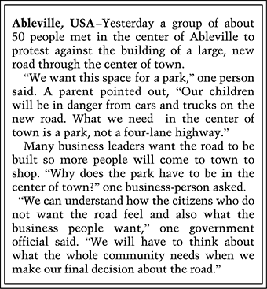
12. What right did the people who protested against the road use?

A. The right to a free press

B. The right to vote

C. The right to a fair trial

D. The right to assemble peacefully

13. What would be another legal way for citizens who are against the road to express their opinions?

A. Blocking the way of construction trucks building the road

B. Presenting their ideas to the city planning board

C. Damaging the road after it is built

D. Opening new businesses near the road

14. What important fact about how a democracy works can be learned from the article?

A. A democratic government must listen to the views of many different people to make decisions.

B. A democratic government listens more to people who complain a lot in newspapers.

C. A democratic government works best when everybody protests.

D. A democratic government works best when everyone has the same opinions.

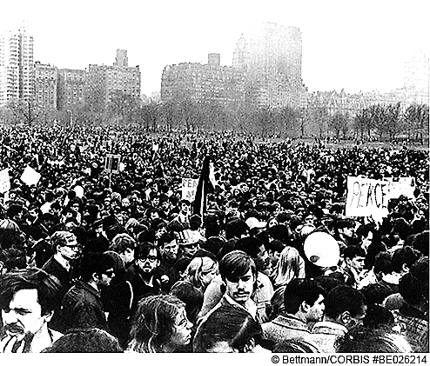

15. The photograph above shows people exercising their right to freedom of assembly. Why is this an important right in a democracy such as ours?

A. It gives people an opportunity to be together.

B. It helps the police keep crowds under control.

C. It allows many people to show their support for an idea.

D. It lets politicians make lots of speeches.

