Name _________________________________________________

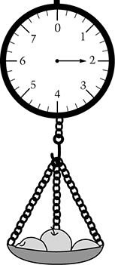

1. How much do these apples weigh?

A. 2 cups

B. 2 feet

C. 2 pounds

D. 2 quarts

2. Mark has nine shirts in his closet as shown. If Mark picks a shirt out of the closet without looking, which two colors have the greatest chance of being picked?

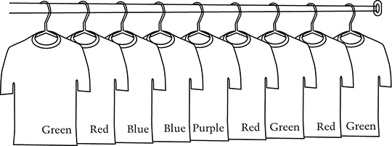
A. Blue and purple

B. Green and blue

C. Red and blue

D. Red and green

3. Last month a musical group had 13 concerts. There were 12,000 tickets printed for each concert. What was the total number of tickets printed last month?

Answer: tickets

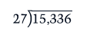
4. Divide:

- 0.00176

- 56.78

- 568

- 17,605

INPUT | OUTPUT
0 | 0
1 | 2
2 | 4
3 | 6

5. Which rule works for every pair of numbers in the INPUT-OUTPUT table?

A. Each OUTPUT number is equal to the INPUT number.

B. Each OUTPUT number is one more than the INPUT number.

C. Each OUTPUT number is two more than the INPUT number.

D. Each OUTPUT number is two times the INPUT number.

6. Which statement is true about all four shapes shown?

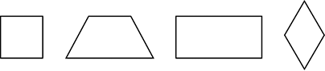
A. Each shape is a rectangle.

B. Each shape is a quadrilateral.

C. Each shape has two pairs of parallel sides.

D. Each shape has one or more right angles.

7. Elsa works at the library. She puts a total of 54 books onto 3 shelves. Elsa puts at least 16 books on each shelf. Complete the table to show one way Elsa could put the books on the shelves.

Shelf | Number of Books
1
2
3
Total | 54

8. Ned is taller than both Paul and Juan. Eric is shorter than Juan but taller than Paul. Juan is 66 inches tall.

Which boy is shortest? _______________

Which boy is tallest? _________________

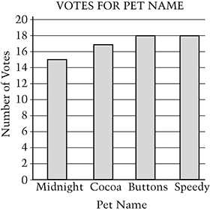
9. The fourth graders voted for a name for their pet. The graph shows the result of the vote. The students voted a second time. For the second vote, 4 students changed their vote from Buttons to Midnight. All other students voted for the same name they voted for the first time. Which name had the most votes the second time?

A. Midnight

B. Cocoa

C. Buttons

D. Speedy

10. Pablo connected points, with straight line segments, in the following order:

A to B
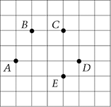
B to C
C to D
D to A

What shape did he make?

A. Hexagon

B. Pentagon

C. Rectangle

D. Trapezoid

11. Andy has three cards, A, B, and C. Each card has one number on it.

One card has the number 4 on it.
One card has the number 6 on it.
One card has the number 10 on it.

The number on card B is a factor of 8, and the number on card C is a factor of 12. Write the correct number on each of the cards below so that they are the same as Andy’s cards.

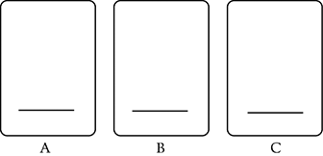

12. There are 22 students in a class. There are 12 girls in the class. What is the ratio of the number of boys to the number of girls in the class?

A. 10 to 12

B. 10 to 22

C. 12 to 10

D. 22 to 12

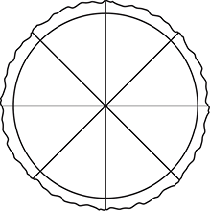
13. Nick has a whole pizza. Nick says he will eat of the pizza. He says he will give of the pizza to Sam and of the pizza to Joe. Can Nick do what he says?

Yes No

Explain or show why or why not.

School | Length of Floor | Width of Floor
Adams | 95 ft | 40 ft
Brooks | 90 ft | 55 ft
Carter | 100 ft | 50 ft
Dunbar | 85 ft | 60 ft

14. The table shows the length and the width of the gym floors in four schools. Each floor is in the shape of a rectangle. Which schools gym floor has the greatest area?

A. Adams

B. Brooks

C. Carter

D. Dunbar

15. A yellow box holds 72 pencils. Two red boxes hold as many pencils as one yellow box. Three blue boxes hold as many pencils as one red box. How many pencils does one blue box hold?

Answer:

Show or explain how you got your answer.

