1. What is the length of segment AB shown?

A. 0.52 millimeter

B. 0.52 centimeter

C. 5.2 millimeters

D. 5.2 centimeters

E. 520 millimeters

2. A nickel, a dime, and a quarter are flipped at the same time. Each coin can land either heads up (H) or tails up (T). List all the different possible outcomes for this event in the chart below. The list has been started for you.
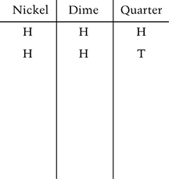

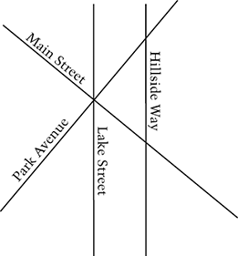
3. In the map above, which two streets appear to be perpendicular to each other?

A. Hillside Way and Lake Street

B. Lake Street and Park Avenue

C. Park Avenue and Hillside Way

D. Main Street and Hillside Way

E. Main Street and Park Avenue

4. Which pair of rays forms an angle of 30 degrees?

A. 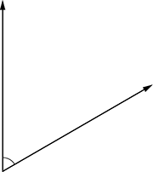

B.

C. 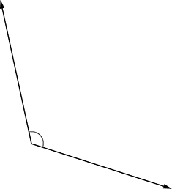

D. 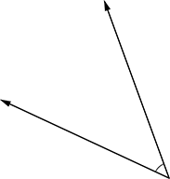

E. 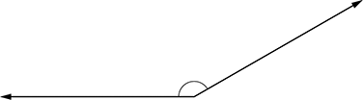

5. Rima and Eric have earned a total of 135 tokens to buy items at the school store. The ratio of the number of tokens that Rima has to the number of tokens that Eric has is 8 to 7. How many tokens does Rima have?

A. 8

B. 15

C. 56

D. 72

E. 120

6. Points A and B are on a number line. The coordinate of point B is 3 and the coordinate of the midpoint of segment AB is . What is the coordinate of point A ?

A.

B.

C.

D.

E.
7. Rick has earned a total of 581 points on all of his science tests. His overall test average (mean) is 83. How many tests has Rick taken?

A. 6

B. 7

C. 8

D. 9

E. 10

8. Martine is filling a rectangular fish tank using two hoses that fill the tank at the same flow rate. When the tank is about half full, she turns off one hose but does not change the flow rate of the other hose. Which of the following graphs best represents how the depth of the water in the tank changes over time?

A. 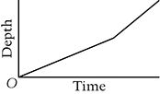

B. 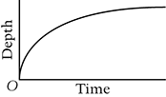

C. 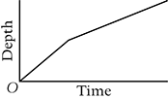

D. 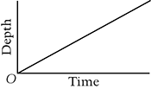

E. 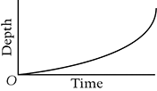

9. In which of the following equations does the value of y increase by 6 units when x increases by 2 units?

A.

B.

C.

D.

E.

10. Last month Bonnie recorded the weights of 11 dogs. Statistics for these weights are given below.
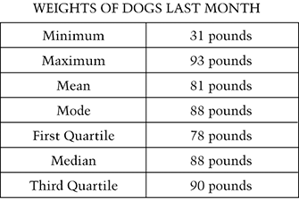
This month, Bonnie weighed the 11 dogs again. The weight of one dog changed from 31 pounds to 27 pounds. The weights of all the other dogs stayed the same.

Which of the following statistics changed from last month to this month?

A. Maximum

B. Mean

C. Mode

D. First Quartile

E. Median
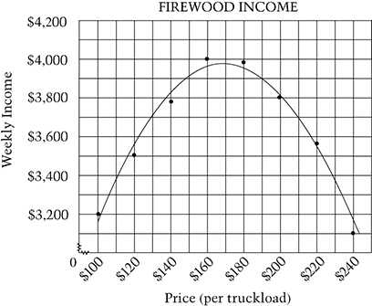

11. The Atwood family sells firewood. They keep track of how their weekly income varies with the price they set for the firewood. In the graph below, the relationship between the price per truckload and weekly income is modeled by the curve.

About how many truckloads of firewood would the Atwood family expect to sell at $170 per truckload?

Answer:_________________________

Show how you found your answer.

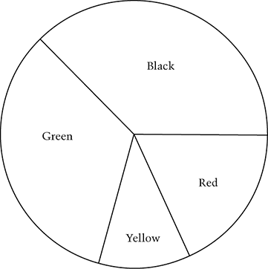
12. The figure shows a game board. What is the measure, in degrees, of the largest section of the board?

Answer: _____________________

13. On a floor plan, a length of 1 inch represents 4 feet. Which of the following segments would represent an 11-foot-long wall on this floor plan?

A.

B.

C.

D.

E.

14. Archaeologists measure the lengths of certain bones to estimate a dinosaur’s height. When the length t of the tibia, or leg bone, is known, a dinosaurs height h can be estimated by the following formula, where t and h are in centimeters.

If the length of the tibia of a certain dinosaur is 400 centimeters, what is its estimated height in centimeters?

A. 402.5

B. 473

C. 475.5

D. 1,000

E. 1,073

15. Fill in the table below so that the points with coordinates all lie on the same line.

