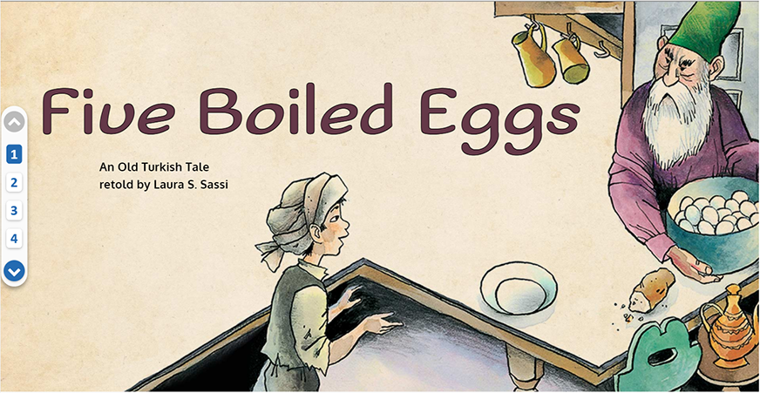

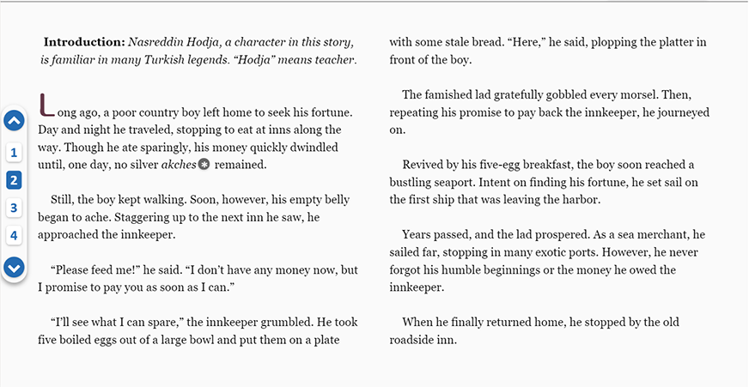

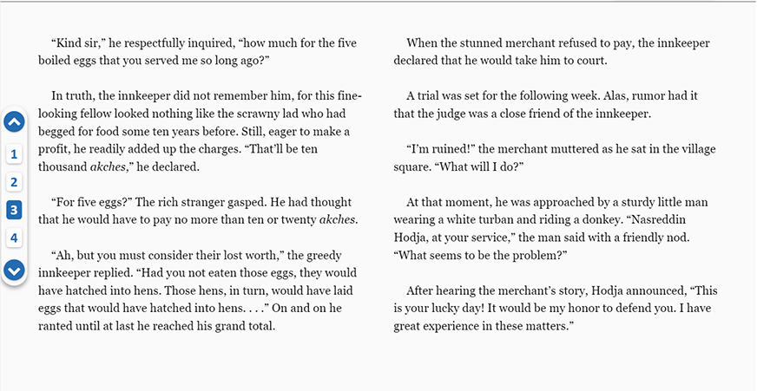

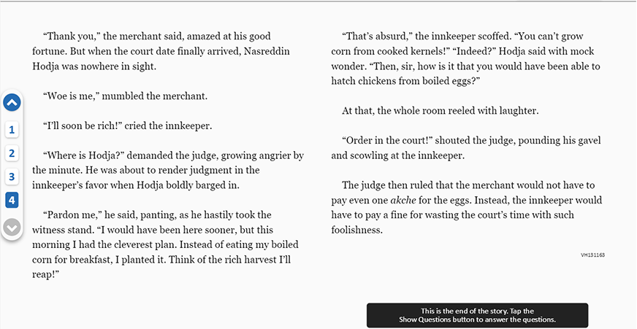

Copyright © 2004 Highlights for Children, Inc., Columbus, Ohio.

- What did the boy do to become successful?

- He raised hens from the eggs the innkeeper gave him.

- He became a sea merchant and traveled to many places.

- He learned from the innkeeper how to make his fortune.

- He borrowed money to buy a new sailing ship.

- When the boy asks for food, the innkeeper says, “I’ll see what I can spare.” This means that the innkeeper

A. wants the boy to pay for the food

B. has to prepare extra food for the boy

C. is willing to give up some food

D. is worried that the food is stale

- Describe what kind of person the merchant is. Give one detail from the story to support your answer.

- The innkeeper says the merchant owes him ten thousand akches. What reason does the innkeeper give for that amount?

A. Eggs have become more expensive.

B. The merchant has taken too long to repay him.

C. Hens would have hatched from the eggs.

D. The merchant has promised to pay any price.

- The story says that the innkeeper was “eager to make a profit.” This means that the innkeeper

A. had a dishonest plan to make money

B. thought a lot about how to make money

C. tried to make money by raising prices

D. really wanted to make money

- Do you think that the innkeeper changes in the story? Use specific information from the beginning and end of the story to support your opinion.

- The merchant mutters, “I’m ruined!” Explain what the merchant means when he says this. Use information from the story in your answer.

- What is the main reason Nasreddin Hodja tells the judge about the corn?

A. To suggest that the corn could be harvested

B. To win the court case for the merchant

C. To make the judge become even angrier

D. To make the people in the courtroom laugh

- Who do you think is the most important character in the story? Explain your opinion using specific information from the story.

- Why does the judge decide that the merchant does not have to pay?

A. Nasreddin Hodja shows that the innkeeper's demand is silly.

B. The innkeeper finally agrees that the merchant is right.

C. The amount of money the innkeeper wants is much too high.

D. Nasreddin Hodja proves that he is a good friend of the judge.

