- Item Detail for Question 1: No student responses are available for this question.

- Item Detail for Question 2

Full comprehension - Student Response
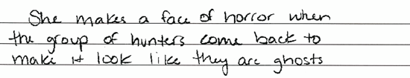
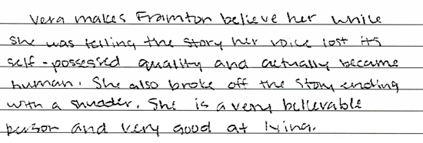

Both responses use specific details from the story to explain how Vera made Framton believe her. The first response describes the way in which Vera told her story in order for it to be convincing. The second response explains one thing Vera does and why it would make Framton believe her.

Partial comprehension - Student Response
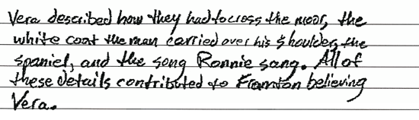
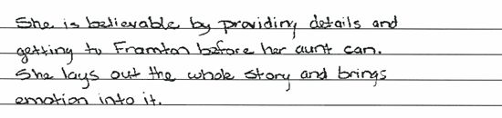

Both responses provide some explanation of why Vera was convincing. The first response provides a text-based generalization that describes what Vera does to make Framton believe her. The second response provides specific details that Vera uses in her story, but it does not explain why these details would be convincing.

Little or no comprehension - Student Response

The first response merely states that Vera tells the story about her aunt, but does not explain how Vera tells it or what she includes in the story that would make it convincing. The second response describes Vera as convincing, but does not explain how Vera is convincing.

- Item Detail for Question 3

Full comprehension - Student Response
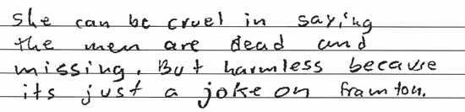
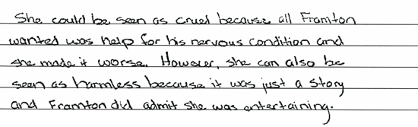

Both responses provide a text-based explanation for how Vera could be viewed as both cruel and harmless. The first response points out that making Framton's nervous condition worse was cruel, but the fact that Vera was simply telling a story shows that she can be seen as harmless. The second response connects the cruel aspect to Vera's saying the men were dead but indicates that the story is harmless because she was just playing a joke.

Partial comprehension - Student Response
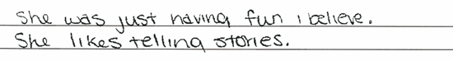
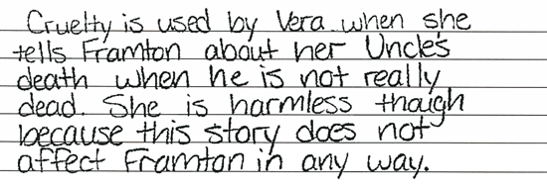

The first response describes only how Vera can be viewed as cruel. The second sentence is not correct and therefore is not given credit for discussing the harmless aspect. The second response explains only how Vera's character can be viewed as harmless because her telling stories was just for fun.

Little or no comprehension - Student Response
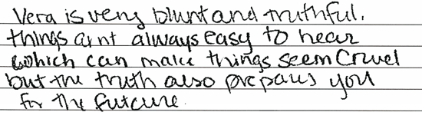
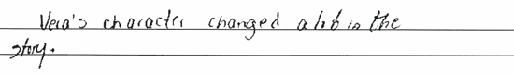

-------------------------------------------------------------------------------------------------------------------------------------------------------------------------
The first response provides an incorrect assertion. The second response provides a personal opinion that is not supported by the text.

- Item Detail for Question 4: No student responses are available for this question.

- Item Detail for Question 5

Extensive - Student Response
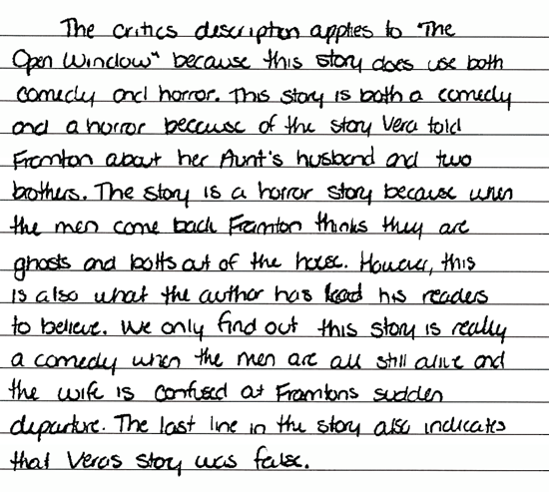
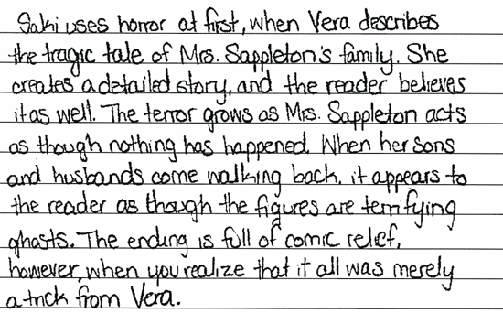

Both responses demonstrate an understanding of how the author uses comedy and horror in the story. These responses recognize that the horror story within the story that is told by Vera draws the reader in as it does the character of Framton. These responses also recognize that the comedy results from the reader's realization that Vera's story was not true.

Essential - Student Response
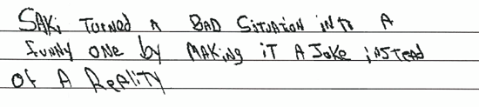
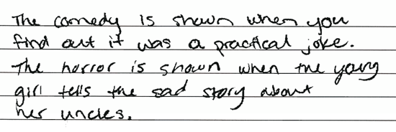

The first response demonstrates an understanding that the comedy results from the revelation that Vera's story was a kind of joke, but describes the horror only in terms of plot. The second response demonstrates a general understanding of how the story works in that the story-within-the story is a joke.

Partial - Student Response
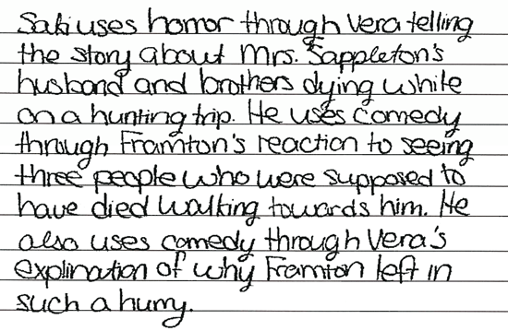
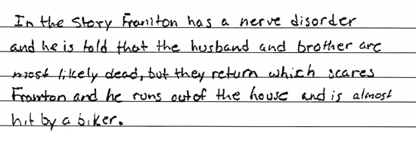

The first response describes the horror that the character of Framton experiences because he believes Vera's story. The second response demonstrates understanding of what in the plot is horror and what is comedy. Neither response recognizes that the author uses Vera's story to affect the reader.

Unsatisfactory - Student Response
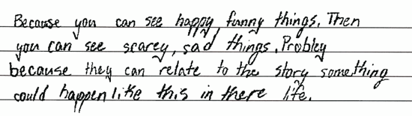
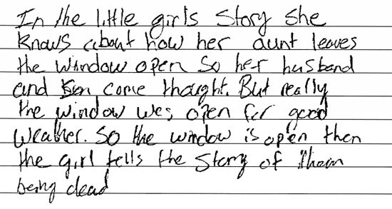

The first response refers to Vera's story as if it were true and includes an incorrect interpretation. The second response provides vague comments that do not address how comedy and horror apply even at the plot level.

- Item Detail for Question 6

Full comprehension - Student Response
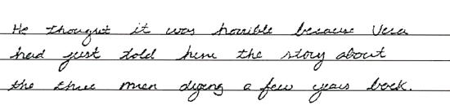
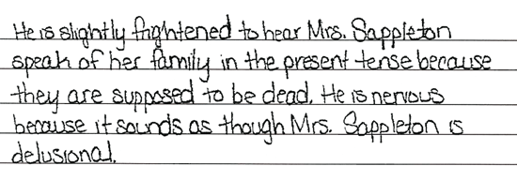

Both responses provide a description of Framton's reaction and explain why he reacts as he does. The first response more than answers the question by providing two reactions, each of which is explained. The second response succinctly provides Framton's reaction and an explanation.

Partial comprehension - Student Response
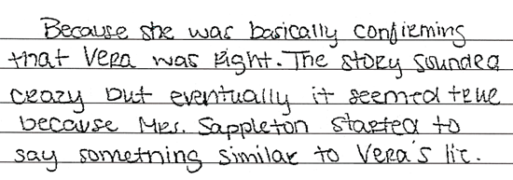
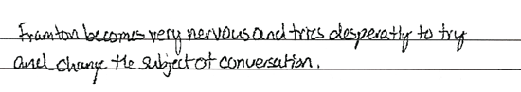

The first response describes Framton's reaction as nervousness, but only tells what Framton does in the story, not why he reacts as he does. The second response provides an explanation for Framton's reaction but does not describe his reaction.

Little or no comprehension - Student Response
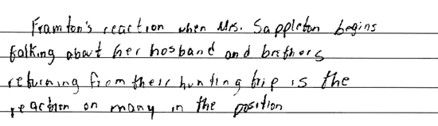
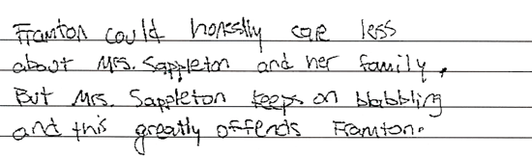

The first response provides personal opinions supported by irrelevant details from the story. The second response merely rephrases the prompt, without providing either Framton's reaction or an explanation.

- Item Detail for Question 7

Acceptable - Student Response
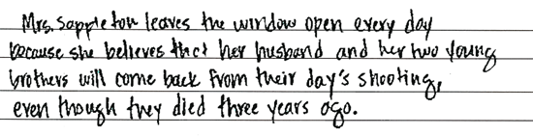
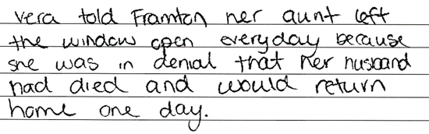

Both responses demonstrate understanding of Vera's fictional account of why her aunt, Mrs. Sappleton, leaves the window open. The first response uses the implication of Vera's fiction, which is that her aunt refuses to accept reality. The second response provides a more straightforward description of Vera's story about her aunt's belief that her husband and brothers will return.

Unacceptable - Student Response
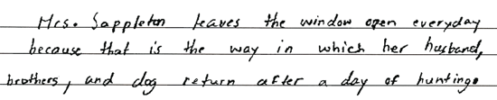
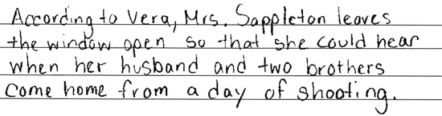

Both responses provide the actual reason why Mrs. Sappleton leaves the window open in the story, but do not address the reason as expressed in Vera's story within the story.

- Item Detail for Question 8

Acceptable - Student Response
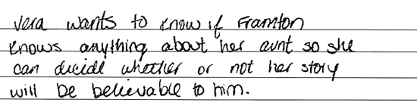
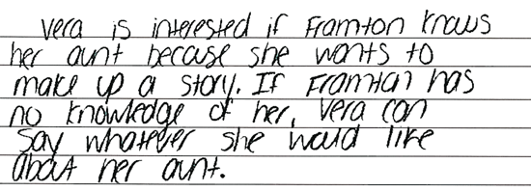

Both responses demonstrate understanding of Vera's motive in asking about the extent of Framton's knowledge of her aunt. The first response explains the motive as determining what Vera can make up about her aunt. The second response explains the motive in terms of the how believable Vera's story will seem to Framton.

Unacceptable - Student Response
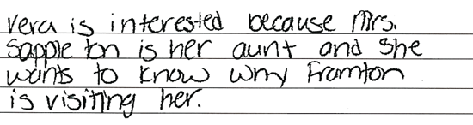
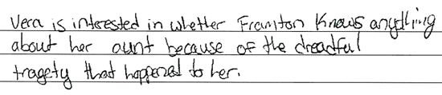
-------------------------------------------------------------------------------------------------------------------------------------------------------------------------
Both responses use details from the story that are not relevant to Vera's motivation. The first response uses details from Vera's story as if the events really happened. The second response refers to Framton's motivation for visiting her aunt.

- Item Detail for Question 9: No student responses are available for this question.

- Item Detail for Question 10: No student responses are available for this question.

- Item Detail for Question 11: No student responses are available for this question.

