Enemy Pie
by Derek Munson illustrated by Tara Calahan King

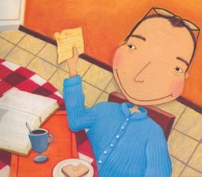
It was a perfect summer until Jeremy Ross moved in right next door to my best friend Stanley. I did not like Jeremy. He had a party and I wasn’t even invited. But my best friend Stanley was.
I never had an enemy until Jeremy moved into the neighborhood. Dad told me that when he was my age, he had enemies, too. But he knew of a way to get rid of them.
Dad pulled a worn-out scrap of paper from a recipe book.
“Enemy Pie,” he said, satisfied.
You may be wondering what exactly is in Enemy Pie. Dad said the recipe was so secret, he couldn’t even tell me. I begged him to tell me something—anything.
“I will tell you this, Tom,” he said to me. “Enemy Pie is the fastest known way to get rid of enemies.”
This got me thinking. What kinds of disgusting things would I put into Enemy Pie? I brought Dad earthworms and rocks, but he gave them right back.
I went outside to play. All the while, I listened to the sounds of my dad in the kitchen. This could be a great summer after all.
I tried to imagine how horrible Enemy Pie must smell. But I smelled something really good. As far as I could tell, it was coming from our kitchen. I was confused.
I went inside to ask Dad what was wrong. Enemy Pie shouldn’t smell this good. But Dad was smart. “If it smelled bad, your enemy would never eat it,” he said. I could tell he’d made this pie before.
The oven buzzer rang. Dad put on oven mitts and pulled out the pie. It looked good enough to eat! I was beginning to understand.
But still, I wasn’t sure how this Enemy Pie worked. What exactly did it do to enemies? Maybe it made their hair fall out, or their breath stinky. I asked Dad, but he was no help.
While the pie cooled, Dad filled me in on my job.
He whispered. “In order for it to work, you need to spend a day with your enemy. Even worse, you have to be nice to him. It’s not easy. But that’s the only way that Enemy Pie can work. Are you sure you want to do this?”
Of course I was.
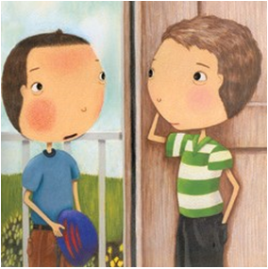
All I had to do was spend one day with Jeremy, then he’d be out of my life. I rode my bike to his house and knocked on the door.
When Jeremy opened the door, he seemed surprised.
“Can you come out and play?” I asked.
He looked confused. “I’ll go ask my mom,” he said. He came back with his shoes in his hand.
We rode bikes for a while, then ate lunch. After lunch we went over to my house.
It was strange, but I was having fun with my enemy. I couldn’t tell Dad that, since he had worked so hard to make the pie.
We played games until my dad called us for dinner.
Dad had made my favorite food. It was Jeremy’s favorite, too! Maybe Jeremy wasn’t so bad after all. I was beginning to think that maybe we should forget about Enemy Pie.
“Dad”, I said, “It sure is nice having a new friend.” I was trying to tell him that Jeremy was no longer my enemy.
But Dad only smiled and nodded. I think he thought I was just pretending.
But after dinner, Dad brought out the pie. He dished up three plates and passed one to me and one to Jeremy.
“Wow!” Jeremy said, looking at the pie.
I panicked. I didn’t want Jeremy to eat Enemy Pie! He was my friend!
“Don’t eat it!” I cried. “It’s bad!”
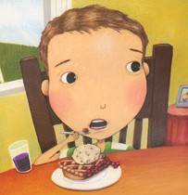
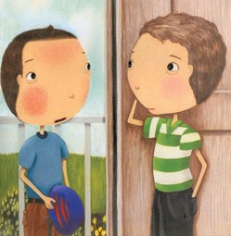
Jeremy’s fork stopped before reaching his mouth. He looked at me funny. I felt relieved. I had saved his life.
“If it’s so bad,” Jeremy asked, “then why has your dad already eaten half of it?”
Sure enough, Dad was eating Enemy Pie.
“Good stuff,” Dad mumbled. I sat there watching them eat. Neither one of them was losing any hair! It seemed safe, so I took a tiny taste. It was delicious!
After dessert, Jeremy invited me to come over to his house the next morning.
As for Enemy Pie, I still don’t know how to make it. I still wonder if enemies really do hate it or if their hair falls out or their breath turns bad. But I don’t know if I’ll ever get an answer, because I just lost my best enemy.
- Who is telling the story?
  - Jeremy
  - Dad
  - Stanley
  - Tom
- At the beginning of the story, why did Tom think Jeremy was his enemy?

- Write one ingredient that Tom thought would be in Enemy Pie

- Find the part of the story next to the picture of a piece of pie: Why did Tom think it could be a great summer after all?
  - He liked playing outside.
  - He was excited about Dad’s plan.
  - He made a new friend.
  - He wanted to taste Enemy Pie.
- How did Tom feel when he first smelled Enemy Pie? Explain why he felt this way.

- What did Tom think could happen when his enemy ate Enemy Pie? Write one thing.

- What were the two things Tom’s dad told Tom to do for Enemy Pie to work?

- Why did Tom go to Jeremy’s house?
  - To invite Jeremy to dinner.
  - To ask Jeremy to leave Stanley alone.
  - To invite Jeremy to play.
  - To ask Jeremy to be his friend.
- What surprised Tom about the day he spent with Jeremy?

- At dinner, why did Tom begin to think he and his dad should forget about Enemy Pie?
  - Tom did not want to share dessert with Jeremy.
  - Tom did not think Enemy Pie would work.
  - Tom was beginning to like Jeremy.
  - Tom wanted to keep Enemy Pie a secret.
- How was Tom feeling when Dad passed the piece of Enemy Pie to Jeremy?
  - alarmed
  - satisfied
  - surprised
  - confused
- What was it about Enemy Pie that Dad kept secret?
  - It was a normal pie.
  - It tasted disgusting.
  - It was his favorite food.
  - It was a poisonous pie.
- Look at this sentence from the end of the story: “After dessert, Jeremy invited me to come over to his house the next morning.” What does this suggest about the boys?
  - They are still enemies.
  - They do not like to play at Tom’s house.
  - They wanted to eat some more Enemy Pie.
  - They might be friends in the future.
- Use what you have read to explain why Tom’s dad really made Enemy Pie.

- What kind of person is Tom’s dad? Give an example of what he did in the story that shows this.

- What lesson might you learn from this story?

